FINDING OUR WAY: a Workshop on Self Re-Discovery
Winter 2018
Osher LifeLong Learning Institute and
Reston Community Center Lifelong Learning Program

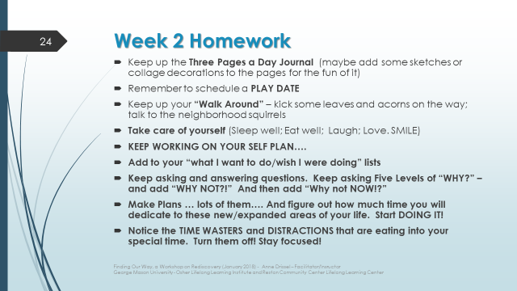

Anne Drissel, Workshop Lead
Drisselab@gmail.com
Cell phone: 301-908-5041

Notes after Session 2 – Ideas leading to and from homework…

Path to follow: observe –> contemplate –> understand –> do.
Notice: over time, what seemingly small steps or actions proved to be MAJOR or significant life choices? Why were they major and what led to them…. And what became of you from that choice?

Notice your thinking.
It is important to notice what you are thinking and to decide whether your current/active thoughts (and resulting decisions and actions) are the ones you prefer over alternatives.

Noticing the “Rules I Hold Myself To”

Look back at the “rules” (learned from parents, family, friends, community, church, ec.) that enabled you to be successful in the past.

What rules did I learn or invent that enabled me to
– Be captain of the football team in high school
– Lead the debating team in college
– Graduate with a near 4.0 (or whatever level I achieved) in college
– Meet my spouse or partner
-- Head the PTA at my kids’ school
– Manage the local soccer league
– Become director of a major research lab
-- Direct a government agency
-- Write the poem that was published in that professional journal
-- Be a successful metal worker/builder/shop foreman/ lawyer/teacher, etc.

Notice the rules that run through your head – all day, every day. About how you drive… How you greet new people. What you let yourself do – or not do. What you “say” you are or aren’t. What you say to yourself that you like or don’t like. Are they really YOU? The YOU you want to be now? The YOU you are becoming?

- What are the “rules I hold myself to” regarding how I master tasks or skills?
- What are my rules about whether I say I did something well or failed to meet my standards? How do I measure mastery?
- What are the “rules I hold myself to” regarding survival/ perseverance/persistence in the face of adversity or failure or obstacles??
- What do I tell myself when something goes wrong or I don’t do a new thing perfectly when I start out?
- What are the “rules”….

Write them down and reflect on them. Are they valid and valuable motivators for the “present and growing forward” YOU? Or are they getting in your way now?
(Note: If you want to get creative about these: decorate or collage them and hang them on a wall or a bathroom mirror to remind yourself to notice and affirm these rules --- or to remind yourself they no long apply to your new SELF/Lifestyle)
====================

Noticing New Patterns: Pay attention especially to thoughts that are hard to put into words. They are likely to be new ideas - imaginings, not yet formed thoughts – They may be emerging new patterns for you. They can be / are likely to be very important!

- What were the messages my kids/friends chose for my birthday card or posted on my Facebook page? What were they signaling about how they value me and what I bring to their lives?
- What life signals am I noticing now? What used to interest me but bores me now? What am I curious about?
- What books in my library shelves call my attention? What are they suggesting? What have I noticed drew my attention as I was browsing a bookstore recently or noticing on the shelves of a friend’s library?
- What conversation fragment at that recent “happy hour” keeps sticking in the back of my mind?
- What dream keeps showing up? What do I day dreaming about?
- What do I keep wishing I had done? What do I envy about a friend or colleague because I wanted to do/be that?

Reinforcing Patterns :

Emerging discoveries in neuroscience are widening our understanding of brain functioning. One complex area is the functioning of “glial cells” which make up the predominant mass of the human brain. Only recently have high-powered microscopes enabled study of these cells. What is being learned is how these cells fundamentally influence the electrical impulses in the brain, sensing reinforcing, strengthening, speeding/slowing flow, and clearing away “dead” cells.

One might also use descriptions of these brain functions as a metaphor for how we live in our own world and how we shape our lives and influence the world around us. (What have people said about you when you move away, leave a group, change jobs? What did they notice about how you operate(d)?

- How did/do I notice and pay attention to new/emergent patterns, passions, desires?
- How did/do I sense and monitor movement, changes, progress (In myself? My work team? My family? -- friendships? My community?)
- How did/do I message or promulgate – publish – disseminate my ideas or emergent patterns and information to others?
- What did/do I do with my noticing? How did/do I shape and influence ….
  - How do I influence direction, progress, movement?
  - What do I choose to reinforce
  - What did/do I strengthen and build? How? Why? How did I decide?

Remember, your current thoughts and actions are shaping your life…

- My thoughts are a rich creation unique to me
- I have everything I need to manage my thoughts.
  - I am my own fearful thoughts
  - I am my own bounded space.
  - I’m the one who feels sadness and losses.
- I’m the one who observes beauty and rejoices in it.
- By my thoughts and actions In this moment, I’m the one who can add joy to my life, my family and friends, my community, the Earth
  - What do I choose to reject and clear aside

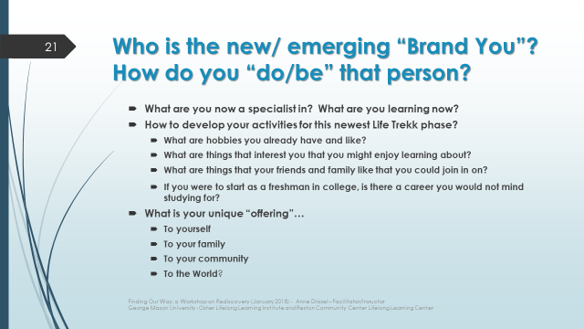
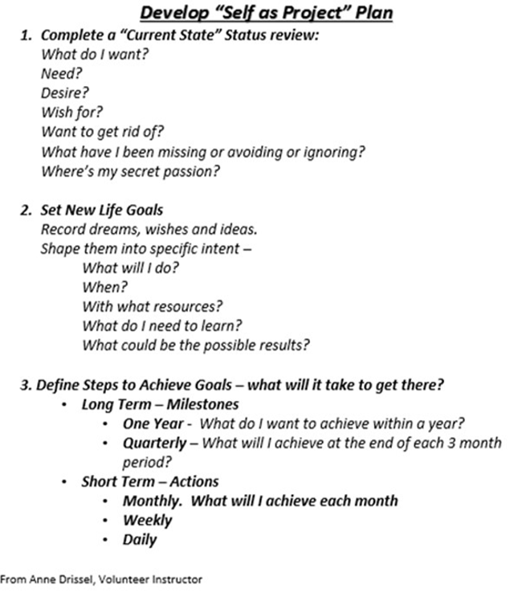

See THE OTHER BRAIN by R. Douglas Fields Ph.D. (Author). Also: https://www.nature.com/news/neuroscience-map-the-other-brain-1.13654

