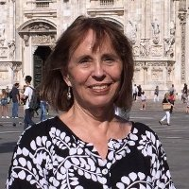 | From the Desk of  Anne Drissel  Life Coach, Change Artist and  Stability Manager  Drisselab@gmail.com

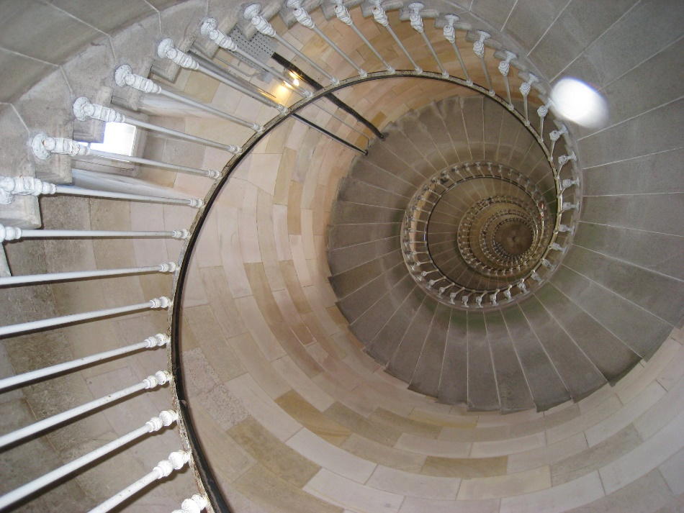
Photo by Anne Duncan, Paris 2014 ©

Reflections on Moving On
By Anne B. Drissel ~November 2016
Throughout my working career, I specialized in bringing new missions, visions and products into fruition and occasionally restructuring floundering organizations to restore them to their original bright aspirations. This work often entailed a complete change in specialty focus and physical relocation – including cross-country moves. I seemed to adapt readily to the necessary life adjustments that came with these job changes.
But it wasn’t until I retired that I had to come to terms with the fundamental construct of the paid-work world that I had relied on to order my life. Yes I basked in the luxury of freely chosen wake-up times, daytime art and exercise classes, uninterrupted reading times -- essentially infinite choice in what to do with my days. I wasn’t prepared for the yawning gap that soon opened up as I realized my whole self-construct had been scuttled. Belatedly I came to appreciate that “work” had provided essential constructs for my life that I relied on:
- Structure
- Large, meaningful tasks
- Mattering
- Companionship/team
- Specific tasks
- Accountability
- Money
- Reward
- Measured progress
- A “forward/upward” direction
My entire day had been STRUCTURED around work. Where I worked established the context for where and how I lived. The daily work mode established my pattern for what time I work up, how much time I had for coffee and the news. I wasn’t a “morning person” but breakfast meetings of the hospital board started at 7 or 7:30 AM. Meetings in the IT world generally started mid-morning. What I wore was determined by the role I played and the people I worked with. What mode of transportation I used depended on where I worked – in a snow drifted town I might get to work in a front-loader; in an urban world a subway was the only sane mode to use (and, yes, sometimes that was the "insane" mode as well!). I now have all the flexibility I wanted to structure my days.
My work provided LARGE, MEANINGFUL TASKS that offered endless challenges. There was a sense of PURPOSE. MISSION. Regulations needed to be interpreted and applied in order to carry forward Congressional legislative intent. New legislation needed to be written to align with changing needs. Buildings needed to be re-conceptualized and rebuilt. Regional and nationwide healthcare delivery systems needed to be improved. New skills needed to be acquired. IT systems with global impact needed to be designed and built and managed. I have time now and infinite options to choose purpose, mission, and tasks for decades to come.
Those “larger than self” tasks gave a sense of MATTERING. My colleagues and I cared deeply whether we did my job well. What if I weren’t doing this work or doing it half-heartedly? It mattered to me whether the policy analyses I wrote were clear enough so states and local groups could benefit from them. Patients needed the most advanced treatment provided to them in a caring environment. Identity systems we were responsible for needed to be carefully planned and built lest a dangerous person inadvertently entered the country. What matters to me now? To whom do I matter?
I was surrounded within the organizations where I worked by a broad range of COLLEAGUES who provided COMPANIONSHIP and a sense of TEAM engagement. We held common intent and direction. We discussed. Argued. Agreed and disagreed. Helped and sometimes hindered each other. We met in endless meetings and workgroup sessions. Some were at-a-distance companions, having met at conferences or through email, online learning communities and forum exchanges. But we stayed engaged with each other on a day-to-day basis. Now the daily "touch in" is no longer mitigated by proximity or common tasks. Staying connected requires continued intentionality.
Our work together required planning and execution of SPECIFIC TASKS and ACCOUNTABILITY among us for completion of those tasks, on time, according to accepted standards, using the resources available to us. It wasn’t enough to provide good care to patients – we also had to keep costs under control so the hospital or healthcare system thrived as well. Small things mattered as well as the big ones – and we needed to pay attention to both. Not everyone carried their full weight but we tried to keep each other to account. If I didn’t do my part, I kept others from completing theirs. We are all connected. Now I am my own "leader" and "follower" -- I must set up my own project plans, actions, milestones and remind myself to complete "the next thing" on my lists -- or choose not to. "Going out to play" is now a legitimate task to be completed!
And, yes, the MONEY part. As long as I was working, I could keep payments for salary or contract work flowing into my bank account and 401K or other Investments. Depending on my professional direction, I could move up – or down – the income scale and know that I could be “safe.” I had a self-protective motto: “I can always type.” Some organization somewhere always needed some form of that skill. But when I stepped off the payroll merry-go-round, there are no more gold-rings. The "gold rings" I already collected in the past are what I have to work with now. Growing them will require new forms of magic. Surprisingly the mysterious world of investing is taking more coherent form as I take a more active role in studying it and learning from others.
The REWARDS in the work world included respect and esteem from colleagues. Occasional recognition awards meant more than the actual insignia, plaque or commendation certificate, or financial bonus payment. They meant I had been seen, noticed and my efforts were appreciated by people who mattered to me. Rewards now will be more subtle -- a gift of the unexpected flowering of seeds I plant and nurture in my new world.
Movement along a career path – or onto new career paths served as a means of MEASURING PROGRESS. Changes in positions, titles or grades served as markers of recognition and reward for hard-earned progress, competence, and expertise. When career paths changed, there were new ladders of progression to be climbed. I have unlimited choice now to determine how to measure progress in my life.
Most importantly, paid work had provided me a sense of a “forward/upward” direction. I could imagine myself heading purposefully into the future. There were new paths to be taken. New territories to explore. New career “mountains” to be climbed. The “future” beckoned. Now I'm living in that "future." I have gifted myself with decades of time to trek along new life paths, to explore new areas of mastery. I can't kid myself any longer that "I'm too busy."
Just as I had experienced in the ever-changing career world, I need to pro-actively maintain all these elements in my life – wherever I am and whatever I’m doing. I’m working on them!
~~ Anne Drissel 2016 ©

