An Evening at Downton Abbey

Thank you all for participating! It was so enjoyable sharing our mutual love for the Edwardian period,
and seeing the lovely dresses, hats, jewelry and shawls. Several guests commented as they left that they would love to have more OLLI opportunities for “dress-up.” I will pass those comments on to Florence Adler.

In response to some questions:
- The Grand March was an immutable fixture of formal dancing for centuries. It was an opportunity to show off finery, to see who was in attendance, and to demonstrate social relationships such as engagements or marriages (as a gentleman always partnered his wife, fiancée, or serious interest for that first dance). It also demonstrated social rank, as it was a singular honor to lead. Dancing gradually evolved from “set dancing” involving multiple couples performing various sets of steps, to partner dancing such as the waltz, one-step, or fox trot.
- The on-line resources are innumerable. I particularly recommend these two, and you may wish to subscribe to their e-mail lists and blog.

downtonabbeycooks.com

edwardianpromenade.com

- I’ve included two requested recipes at the end---please let me know if there is any other you would like. kmpablo@cox.net

- Wonderful cookbooks which contain so much more than recipes: (available on Amazon)
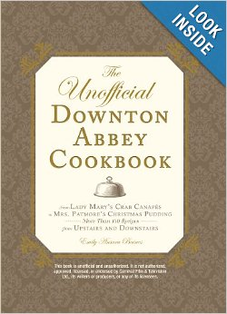

The Unofficial Downton Abbey Cookbook: From Lady Mary's Crab Canapes to Mrs. Patmore's Christmas Pudding - More Than 150 Recipes from Upstairs and Downstairs (Unofficial Cookbook) Hardcover – September 18, 2012
by Emily Ansara Baines (Author)

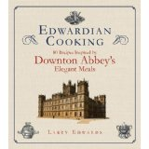 Edwardian Cooking: 80 Recipes Inspired by Downton Abbey's Elegant Meals by Larry Edwards (Nov 13, 2012)
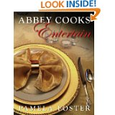

Abbey Cooks Entertain: 220 recipes with photos to help you entertain the Downton way by Pamela Foster (Dec 20, 2012) - Kindle eBook
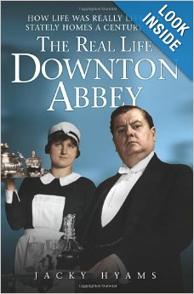

The Real Life Downton Abbey: How Life Was Really Lived in Stately Homes a Century Ago Paperback
by Jacky Hyams (Author)
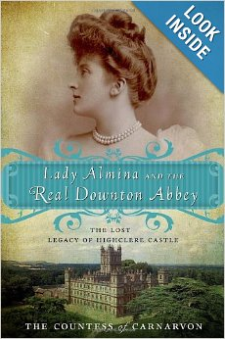
Listen

Lady Almina and the Real Downton Abbey: The Lost Legacy of Highclere Castle Paperback
by The Countess of Carnarvon (Author)
ANZAC Biscuits
Originally developed as an eggless cookie which could be sent to Australian and New Zealand Army Corps soldiers serving in Europe during World War 1. Now universally beloved throughout the British Commonwealth and available commercially.

- 2 cups all-purpose flour
- 2 cups rolled oats
- 2 cups sugar
- 1 cup desiccated coconut
- 1 cup (2 sticks) unsalted butter
- 2 tablespoons Lyle's Golden Syrup (or Karo dark)
- 3/4 teaspoon baking soda
- 1/4 cup boiling water
The dough is very crumbly, but a small ice-cream scoop will enable you to form the biscuits quickly and in a uniform size and shape.
Preheat the oven to 350 degrees. Line baking sheets with parchment paper, and set aside. In a large bowl, combine flour, oats, sugar, and coconut. Set aside.
In a small saucepan over medium heat, melt butter with syrup. Dissolve baking soda in boiling water, and add to butter mixture. Stir to combine. (Be careful; if the butter is hot, it will bubble up considerably.)
Add butter mixture to dry ingredients, and stir to combine. Using a 1 1/2-inch ice-cream scoop, drop onto prepared baking sheets, about 2 inches apart (be sure to pack the scoop tightly so the mixture doesn't crumble). Flatten cookies slightly with the heel of your hand.
Bake until golden brown and firm but not hard, about 15 minutes. Transfer to wire racks to cool.

Eton Mess
Eton mess is a traditional English dessert consisting of a mixture of strawberries, pieces of meringue and cream, which is traditionally served at Eton College's annual cricket game against the pupils of Harrow School. (Wikipedia)

This is the simplest possible dessert, quite showy, and ALWAYS well-received. It was extremely popular during the Edwardian period, and continues so.

- Prepare whatever fruit you wish. I use the frozen mixed berries from Costco. Sweeten to taste and let stand a bit….the sugar will “draw” the fruit, producing the desired juice. If desired, add a liqueur. I used Grand Marnier, but it is not necessary.

- Whip whatever quantity of heavy cream you wish. (For the large trifle bowl I served, I used nearly 4 quarts of cream.)

- Crush meringues (keeping fairly good-sized pieces) in a plastic bag. One can make one’s own meringues, but I buy them from Trader Joe’s.

- Beginning with whipped cream, layer cream, then meringues, then berries. Continue layering.

- If desired, top with toasted sliced almonds.

