eBooks and Mobile Devices

What is an eBook?
A book in digital form, consisting of text, images, or both, and produced on, published through, and readable on computers or other electronic devices

What is OverDrive?
Free software required to download audiobooks and eBooks available at the library
OverDrive is compatible with
Mac OS  Windows 7, XP, 2000, Vista | iPhone, iTouch, iPad  Android  BlackBerry | nook  Sony eReader  Kobo eReader
Computers Mobile Devices eReaders

Log on to OverDrive
- Go to the Fairfax County Library Home Page http://www.fairfaxcounty.gov/library/
- Online Resources and select eBooks
- Scroll down to OverDrive and select Log on

Search for and Download an eBook
  - Search for an eBook title
    - Browse by format/subject or go to Basic search or Expanded search
  - Add to cart
  - Proceed to Checkout
- Enter your library card and password
  - Select a Lending Period
  - Confirm Checkout
  - Select the Download button > Open or Save > Allow
    - Adobe Digital Editions will open (or the set up assistant will appear)
- Log in to Adobe Digital Editions (or create an account)

Transfer an eBook to an eReader
- Select the Library view (book spine icon)
- Plug in your eReader (icon will appear)
- Drag and drop your title onto the eReader icon
- Disconnect eReader from your computer

Search for and download an OverDrive eAudiobook
  - Search for an eAudiobook title that is compatible to your device
    - Browse by format/subject or go to Basic search or Expanded search
  - Add to cart
  - Proceed to Checkout
  - Review the agreement and select Yes (if necessary)
  - Select a Lending Period
  - Confirm Checkout
  - Select the Download button > Allow
  - Select OK or Browse to save eAudiobook
  - Select the parts of the book you wish to download > OK
  - Plug in your device
  - Select Transfer
  - Disconnect eReader from your computer

eReaders

nook
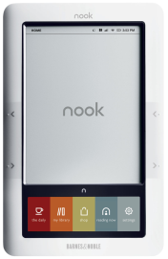
- Holds up to 1,500 books
- LendMe™ technology
  - Lend a book once for up to 14 days
- Connects to Wi-Fi
- Built in dictionary
- “My Shelves”
  - Organize books

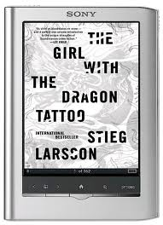
Sony eReader
- Holds up to 1,200 books
- Touchscreen display with stylus
- Built-in Dictionaries and 10 Translators
- Library finder on eBook store
- No Wi-Fi
  - Connects to Sony Daily Edition

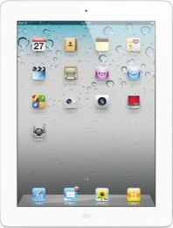
iPad
- Holds several thousand books
- Multi-Touch display
- Built in Apps
- WiFi/3G connectivity

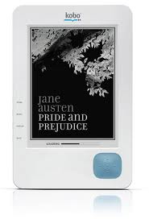
Kobo eReader
- Preloaded with 100 classic titles
- Holds up to 1,000 books
- Built-in dictionary (Kobo Wireless eReader only)

eReader Comparison Chart

 | nook/  nook color | Sony Reader  (Pocket/Touch Daily Edition) | iPad | Borders Kobo Wireless eReader
capacity | 2GB/1,500 books  (expandable) | 2GB/1,200 books  32GB (Touch /Daily Edition expandable) | 16GB-64GB | 1GB/up to 1,000 books (up to 4GB expandable)
color | 16 shades gray/  16 million colors | 8/16 shades gray | yes | 8 shades gray
connectivity | WiFi/3G  (WiFi only on color) | 3G | WiFi/3G | WiFi
cost | $149 WiFi only, $199 WiFi & 3G/$249 nook color, WiFi only | $129-$349 | $499-$829 | $99 (as of 2/8/11)
eBook format | ePub, eReader,  PDF, PDB | ePub, PDF, TXT, RTF, DOC, BBeB Book | ePub  (Kindle, via  app), PDF | ePub, PDF, Adobe DRM
games | limited | no | yes | no
multimedia | audio +  images | images  audio (touch edition) | audio +  video | no
screen size | 6”- 7” | 5”- 7” | 9” | 6”
third-party Apps | yes | no | App Store | no
Web browser | yes | no | yes | no

http://ipod.about.com/od/ipadcomparisons/a/comparing-ipad-kindle-nook.htm

http://www.sonystyle.com/webapp/wcs/stores/servlet/ContentDisplayView?hideHeaderFooter=false&storeId=10151&catalogId=10551&langId=-1&cmsId=reader_kindle_comparison

Resources

OverDrive Digital Media Tutorial
http://www.overdrive.com/products/dlr/tour/Main.html

OverDrive FAQ’s
http://www.overdrive.com/software/omc/faq.asp

http://www.fairfaxcounty.gov/library/faq/overdrivequestions.htm

Device Resource Center
http://www.overdrive.com/resources/drc/compatibledevices.aspx

Adobe Digital Editions
http://www.adobe.com/products/digitaleditions/

nook
http://www.barnesandnoble.com/nook/index.asp
http://nooktalk.net/news/loading-books-with-adobe-digital-editions-on-your-nook

Sony eReader
http://www.sonystyle.com

iPad/iTouch/iPhone
http://www.apple.com/ipad/features/ibooks.html

Kobo eReader http://www.borders.com/online/store/MediaView_koboereaderspecs?ereader=true

