iPad Gee-Wiz/Shortcuts

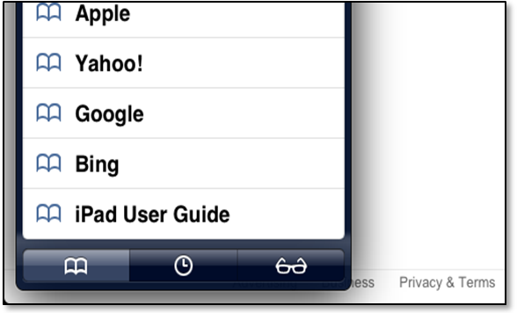

iPad User Guide
Locate last bookmark in Safari, or,
Browse to http://help.apple.com/ipad/6
See Figure 1.

Icon Management
Press and Hold icon to cause icon to “jiggle”
Drag icon to new location
Touch black X to delete from iPad but not from App Store
Figure 1
Drag one icon on top of another to create folder - drag additional icons onto the new folder
Delete folder by dragging each icon out of folder
Press Home Button to turn off jiggle

Multitask with icons
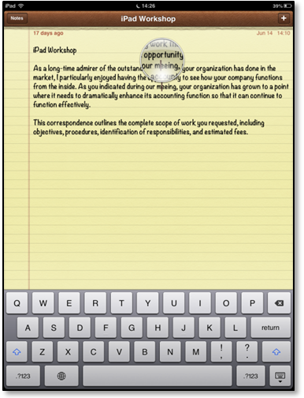Double click home button to view recently used apps.
Tap apps to alternate back and forth
To turn off an app running in background
In the multitasking bar, press and hold that icon until it jiggles, then touch the red circle with the white dash.

Position Curser - In a typed document, to insert curser at a specific point:
With keyboard showing, in the position at which you want to insert the curser, press and hold until a bubble shows. Slide the bubble and or wobble your finger tip until curser is at proper point. Release finger. See Figure 2.

Close Extra Windows in Safari by tapping the “X” in the “Tabbed Browsing Bar” (under the bookmark bar).
Figure 2
Shut down//Reboot
Press and hold down sleep button until red slide arrow appears.
Slide arrow to right - iPad shuts off.
Turn back on - press and hold the sleep button again until the apple logo appears - wait.

