Survey of Non-Traditional Beliefs

1. Session I, September 20

Introduction

Sources

Mystical Traditions

What Is a Mystic

2. Session II, September 27

Karma

Resolution of Karma

3. Session III, October 4

Reincarnation

Akashic Records

4. Session IV, October 11

Free Will Choice

Understanding Karma, Reincarnation and Free Will Choice

5. Session V, October 18

Chakras

Kundalini

**6. Session VI, October 25**

**Astrology**

**Healing Systems**

Additional Discussion Topics

Power of Thoughts

How to Change Your Attitude

Tools from the Kybalion

Lesser Mysteries and Greater Mysteries

Mystery Schools

Ley Lines

Locations with Strong Energy

Already discussed; extra handouts are on the table in front

Classical Elements

Aether, Prana, White Light

Gender and Mental Gender

NOTES:

Linda Bender

[lindabender@starpower.net](mailto:lindabender@starpower.net)

703-451-0253

Astrology

concept

idea that planets/moon/asteroids can affect our lives

appears to have been developed in Mesopotamia around 3000 BCE

Babylon, areas between Tigris and Euphrates, modern Iraq

compare in your minds to the idea of gravity, planets have pull on each other

basic information is based on locations of the planets on your birthday

for a reading astrologer will ask

birth date and time

location of birth

this is a summary with an explanation of what they are talking about

not my area and won’t be--too much memory

all that follows is based on research

just a presentation of core concepts

each of the planets have a meaning, often tied to Greek/Roman mythology

|  |  |
| --- | --- |
| Planet/  Asteroid | Meaning |
| Sun | the self, who you are |
| Moon | emotions, sensitivity |
| Mercury | communications and mental astuteness |
| Venus: | love but also money  (money is considered concretized love by some) |
| Mars | aggression, drive (war like) |
| Ceres | grain and harvest, food |
| Pallas | intelligence, cities |
| Juno | commitment, interact with spouse/partner |
| Vesta | keeper of the hearth |
| Jupiter | growth, expansion |
| Saturn | rules, discipline |
| Chiron | healer, often included as asteroid |
| Uranus | independent |
| Neptune | altered states, dreaming |
| Pluto | sex, death, reincarnation |

Pluto and Neptune discovered relatively recently

have very long orbits

Pluto

discovered on February 18, 1930

takes 248 years to go through a full orbit

will complete one cycle through all the planets in 2178

Neptune

discovered September 23, 1846

takes 165 years to go through a full orbit

completed one cycle through all the planets in 2011

information not published yet

each of the relationships have a meaning

based on the number of degrees between the planets

|  |  |  |  |
| --- | --- | --- | --- |
| Glyph | Degrees | Name | Meaning |
| C:\Users\Linda\AppData\Local\Temp\SNAGHTMLe63e81.PNG | 0̊ | conjunct | two walk in lock step |
|  | 30̊ | semi-sextile | nice but weak |
|  | 60̊ | sextile | better than semi-sextile but weaker than a trine |
|  | 90̊ | square | two planets at cross purposes, not work together well |
|  | 120̊ | trine | two planets working very together well, in tune with each other |
|  | 150̊ | quincunx | hidden disharmony |
|  | 180̊ | opposition | on opposite sides of everything |

each of the signs of the zodiac (aka sun signs) has natures or meanings

sorted by polarity: masculine and feminine

sorted by quality:

cardinal (initiate change)

fixed (stable)

mutable (changeable)

sorted by element:

fire (spiritual)

earth (solid, practical)

air (intellectual, mental)

water (emotional side, flowing)

|  |  |  |  |  |
| --- | --- | --- | --- | --- |
| SUN SIGN | DATES (changes about 21st) | POLARITY | QUALITY | ELEMENT |
| Aries | late March and April | Masculine | Cardinal | Fire |
| Taurus | late April and May | Feminine | Fixed | Earth |
| Gemini | late May and June | Masculine | Mutable | Air |
| Cancer | late June and July | Feminine | Cardinal | Water |
| Leo | late July and August | Masculine | Fixed | Fire |
| Virgo | late August and September | Feminine | Mutable | Earth |
| Libra | late September and October | Masculine | Cardinal | Air |
| Scorpio | late October and November | Feminine | Fixed | Water |
| Sagittarius | late November and December | Masculine | Mutable | Fire |
| Capricorn | late December and January | Feminine | Cardinal | Earth |
| Aquarius | late January and February | Masculine | Fixed | Air |
| Pisces | late February and March | Feminine | Mutable | Water |



Wikipedia: WikiProject Astrology/Glyphs

Houses, areas of activity:

|  |  |
| --- | --- |
| HOUSE | ACTIVITY |
| 1st | rising sign, coming over ascendant when you were born |
| 2nd | manage positions |
| 3rd | neighborhood |
| 4th | foundation, parents, home |
| 5th | play, party |
| 6th | daily routine, health matters |
| 7th | marriage, partnerships |
| 8th | crisis-expert |
| 9th | travel |
| 10th | reputation, as others see you |
| 11th | team player, peer groups |
| 12th | alone, retreat and regroup |

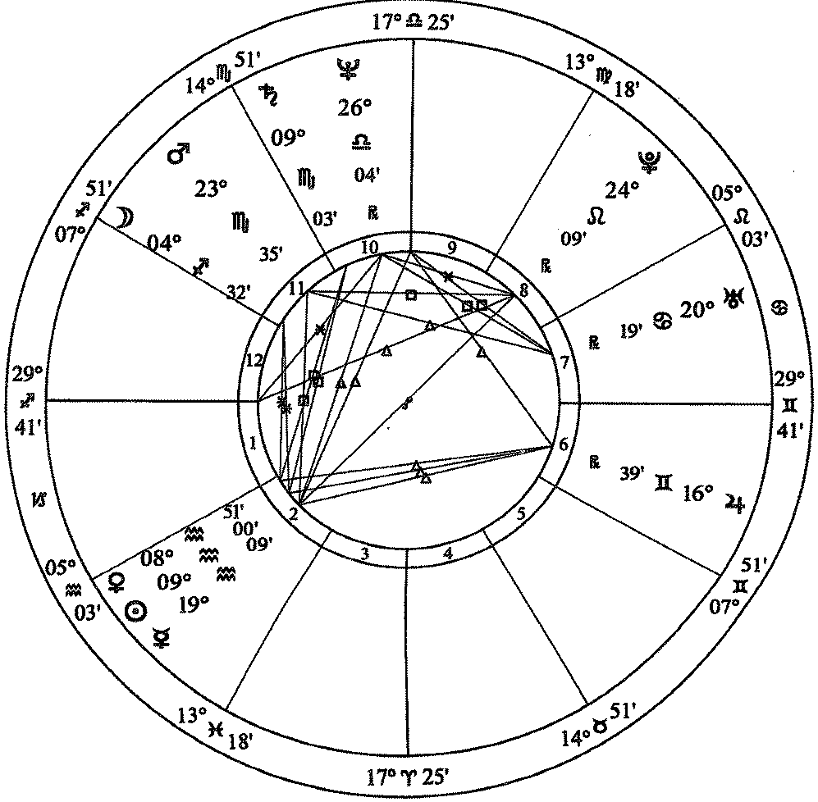

Oprah Winfrey

January 29, 1954 / 4:30 a.m. CST / Kosciusko, MS   
Placidus Houses

From *Llewellyn’s Complete Book of Astrology* by Kris Brandt Riske, MA, page 269

What does it mean if you are born on the cusp

year not always 365 days long

months vary in length, so zodiac months vary in length

most of the time, the end of the zodiac month can be anywhere from 19th to 23rd

if born in that period, are almost always between signs

may have some attributes of both signs

called being “born on the cusp”

can get clarity from the rest of the chart

also important in chart are the ascendant

sun sign that was just coming over the horizon at time of birth

may tell a lot about you

also important may be the moon sign at time of birth

Moon is about the emotions

moon sign tells about emotional self, about private self

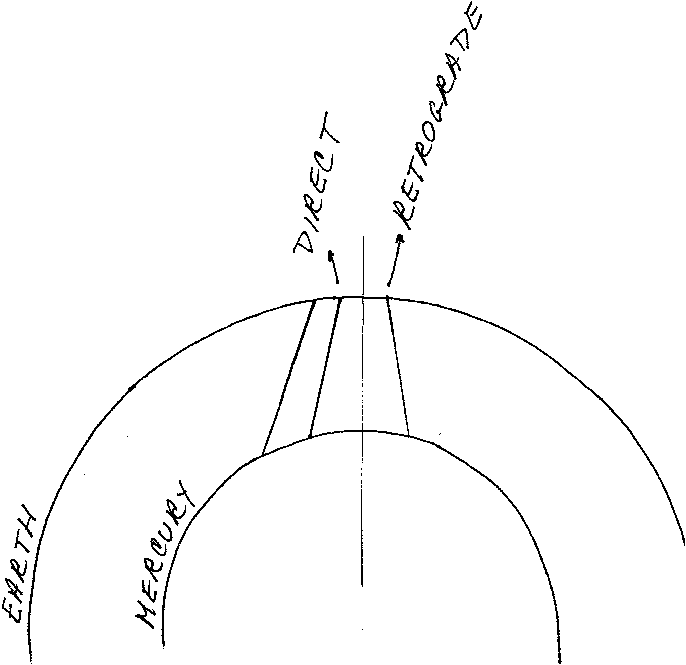

Based on Clement and Bytheriver, *Llewellyn’s New A to Z Horoscope Maker and Interpreter*, p 248

Retrogrades

Mercury goes retrograde 3-4 times a year for a period of three weeks

planet looks like it is going backwards based on our standing on earth

all planets do this except Sun and Moon

if standing on earth and try to see Mercury will have to look back over shoulder

Mercury represents communications/mental alertness

3-4 three-week periods each year

what does it mean:

all kinds of communication issues

meetings fall through

try to make travel connections can be an issue

all kinds of computer issues

generally mind is not as sharp as usual

need to check and recheck info

other planets do this also but for different lengths of time at different times

mean different things based on the meaning of the planet that is retrograde

If you want to have an astrology reading

will get a natal chart that looks like the Oprah Winfrey one

planets and houses

best do a test reading, then ask yourself

does it sound like you

does it make sense to you

do you like the attitude/concepts of the astrologer

absolutely keep a recording of some kind

almost impossible to remember everything

especially helpful if feel that there are things you don’t understand

if you like the astrologer and want annual readings

ask for “solar return”

location of the planets at time of your birthday this year

planets will have moved from where they were are the time of birth

also called a progressed chart

one issue is that readings often (key word) are about people who are younger

hard to get good data after about 50 years old

especially if order a computer-generated reading

most of the time seniors have already worked through many of the issues

seniors don’t worry much about work life/job issues

children are grown and making their own decisions

another issue is that the interpretations are often not consistent

most astrologers doing some kind of research

find a meaning for a planet or relationship

check with other readings and charts they do

if it works well, they then adopt that info and use it

may or may not share at e.g., at an association gathering

may or may not be accepted by others

readers have different meanings for the various planets

means will interpret the aspects differently

can get a computerized reading

then get interpretations of the person who designed the program

Healing Systems

called Complementary and Alternative Medicine (CAM)

some now covered by insurance

is not covered by Medicare

Part D may cover some types

check your insurance carefully for info

as with any healing system, traditional or not,

if you think it will work, helps to make it work more effectively

back to “Thoughts Are Things”

Healing Prayer

part of how I got into non-traditional beliefs

usually no cost involved

no training required, mostly need a desire to help

as part of a healing prayer group

basically think in a positive way about person with illness/challenge

can send wellness energy

can sending healing

better if think about the person in a positive way, not feeling sick

my own system is to find a visual image for person

support works even if I am still hunting for the image!

all this is distance

may or may not get feedback

may find that the person does not want any assistance

lady with the brick wall

just laid the energy on ground where she could reach it if she wished

use healing prayer because it is a very isolated event and

easy to see the dynamics that were at work

unique issue

get help

see results

Reiki

touch healing system

Rei means “God’s Wisdom or the Higher Power”

Ki means “life force energy”

combined means “spiritually guided life force energy”

developed by Dr. Mikao Usui (1865 - 1926)

studied various religions

spiritual experience allowed him to do effective touch healing

before his death, passed the info to Dr. Chujiru Hayashi (1878 - 1940)

he then taught Hawayo Takta

had cured her of a serious illness using Reiki

she then taught it and her grand daughter, Phyllis Lei Furumoto, carried on

training system of three levels

Reiki I

Reiki II

Advanced Reiki Training/Master (ART/Master)

used to be that must then agree to teach to others

not sure of current requirement

have been a number of off shoots or enhancements

names usually have Reiki in the title of the system

two from the Reiki Association web site

Karuna Reiki - “compassionate action”

Holy Fire Reiki

reportedly some 300 derivatives world wide

I find it especially effective and worthwhile

lie on a table, wear comfortable clothing

healer touches various energy points on body

alternate: hands over energy point but not touch, just hover

may ask you to turn over

not invasive in any way

towel or cloth over face so healer can touch face without discomfort

may have more than one healer working at the same time

touch a spot, say forehead or shoulder blades

energy flows from hands of the healer into person being helped

healer holds that position until the flow slows down

when slows means that there has been sufficient energy

moves to another spot

as person being healed, wonderfully relaxing

once finished, feel very balanced, calm

actually does help

probably in part that relax totally

assists body’s own healing systems to be effective

calm, less anxiety about issues

feel that will improve

may be a charge

the environment is important

made appointment for a Reiki session associated with Sinai in Baltimore

near end, I was so calm and relaxed

healer wanted to try rolfing which was his specialty

basically aggressively rolled my arm between his hands

destroyed the relaxation of the Reiki

so plan you time around the Reiki

not have a Reiki session and then run a marathon right away

Therapeutic Touch

basically same idea as Reiki

difference is that it is taught to nurses mostly for inpatient use

developed by Dolores Krieger, PhD, RN and Dora Kunz

Nurse Healers Professional Associates International, Inc.

parent organization

sets standards and does credentialing

their sessions last no more than 20 minutes

large association

headquarters in Delmar, New York

Healing Touch

similar to Therapeutic Touch

Janet Mentgen, the Founder of Healing Touch

believed that anyone could learn how to facilitate healing in others

many of the same kinds of practitioners

nurses, massage therapists, body therapists, counselors, psychotherapists, physicians, other allied health care professionals

Rolfing Structural Integration

system of deep manipulation of the body’s soft tissue

improves posture

relieves chronic pain

reduces stress

developed by Dr. Ida P. Rolf

Ph.D. in biochemistry in 1920

then learned osteopathy

chiropractic medicine

tantric yoga

Alexander tension reduction through body movement

Korzybski’s concept of altered states

created study of “general semantics”

our awareness limited by structure of nervous system

our awareness limited by structure of language

so what we know is filtered through brain/language

used: I don’t know, let’s see.......

Dr. Rolf realized that there were a series of integrated series of tissues

needed to work with all them to reduce stress and manifest healing

get them working together

heals what is called myofascial pain

touch points in the muscles and causes pain elsewhere

used deep massage to reshape the myofascial which reduces pain

Acupuncture

often part of pain management

insert very thin needles through skin

per those who have done it, feel needle go in or come out

not painful, just aware

done along meridians through the body

Chinese technique to balance qi or chi (pronounced CHEE)

Western practitioners use for stimulation

helps blood flow so natural pain killers function better

practitioner should use a fresh set of needles for each treatment

eliminate any danger of infection from previous use

Acupressure

similar to acupuncture but use pressure on the meridian points rather than needles

Reflexology

pressure points on the bottom of the feet are matched to organs

pressure on a particular point on foot sends healing to that organ

listed in University of Minnesota with article

lists with supportive research

Naturopathy

Naturopathy, or naturopathic medicine, is a system of medicine based on the healing power of nature. Naturopathy is a holistic system, meaning that naturopathic doctors (N.D.s) or naturopathic medical doctors (N.M.D.s) strive to find the cause of disease by understanding the body, mind, and spirit of the person.

Source: University of Maryland Medical Center

very holistic, i.e., treat the whole person

practitioners are licensed

Homeopathy

Homeopathy is based on the idea that "like cures like." That is, if a substance causes a symptom in a healthy person, giving the person a very small amount of the same substance may cure the illness. source: WebMD

per NIH, little support evidence for any specific issue

remedies are regulated by FDA but not for safety or effectiveness

Ayurveda

believe that illness comes from lack of balance in energy types:

per University of Maryland Medical Center energy types include:

Vata – Energy that controls bodily functions associated with motion, including blood circulation, breathing, blinking, and heartbeat. When vata energy is balanced, there is creativity and vitality. Out of balance, vata produces fear and anxiety.

Pitta -- Energy that controls the body's metabolic systems, including digestion, absorption, nutrition, and temperature. In balance, pitta leads to contentment and intelligence. Out of balance, pitta can cause ulcers and arouse anger.

Kapha – Energy that controls growth in the body. It supplies water to all body parts, moisturizes the skin, and maintains the immune system. In balance, kapha is expressed as love and forgiveness. Out of balance, kapha leads to insecurity and envy.

General Resources:

Astrology

Associations for Astrologers:

See list at: <http://stariq.com/PageTemplate/t1.asp?PageID=799>

American Federation of Astrologers

seems to have a training and testing program

may be easier to use one of their astrologers

none in the DC, one in Virginia area, are several in Maryland

Healing Systems

Local classes: http://zen.thisistruecs.com/about-kris-brinker/peaceable-dragon/

<http://www.takingcharge.csh.umn.edu/>

University of Minnesota, see “try holistic practices” in top line of page

comprehensive list of the various types of CAM, with links

research and support for various types

Johns Hopkins, Different Types of CAM

http://www.hopkinsmedicine.org/healthlibrary/conditions/adult/complementary_and_alternative_medicine/types_of_complementary_and_alternative_medicine_85,p00189/

NIH, exceptionally long list sorted by medical problem and various solutions

<https://nccih.nih.gov/health/atoz.htm>

WebMD

<http://www.webmd.com/balance/what-is-alternative-medicine>

Alice Steadman, *Who’s the Matter with Me*

Reiki:

<http://medical-dictionary.thefreedictionary.com/Reiki>

general info, good summary

<http://www.reiki.org/>

International Center for Reiki Training

Therapeutic Touch:

<http://therapeutic-touch.org/>

Healing Touch Program™

<http://www.healingtouchprogram.com>

15439 Pebble Gate San Antonio, TX 78232

Phone: 210-497-5529

Rolfing:

<http://www.rolfusa.com/rolfing.html>

<http://medical-dictionary.thefreedictionary.com/Rolfing>

http://www.drweil.com/drw/u/ART00472/Rolfing-Dr-Weils-Wellness-Therapies.html

Acupuncture:

http://www.mayoclinic.org/tests-procedures/acupuncture/basics/definition/prc-20020778

includes information on risks and potential side effects

<http://www.webmd.com/fibromyalgia/tc/acupuncture-topic-overview>

topic says fibromyalgia but article is about acupuncture

<http://www.medicalnewstoday.com/articles/156488.php>

lots of info

Acupressure:

http://www.webmd.com/balance/guide/acupressure-points-and-massage-treatment

<http://www.acupressure.com/>

a number of images on people using the pressure points

Reflexology:

<http://www.takingcharge.csh.umn.edu/>

University of Minnesota, see “try holistic practices” in top line of page

http://www.mayoclinic.org/healthy-lifestyle/consumer-health/expert-answers/what-is-reflexology/faq-20058139

Naturopathy:

<https://nccih.nih.gov/health/naturopathy>

what a naturopath does and how he/she works

Homeopathy:

<http://www.nationalcenterforhomeopathy.org/>

<http://www.webmd.com/balance/guide/homeopathy-topic-overview>

<https://nccih.nih.gov/health/homeopathy>

comprehensive discussion

Ayurveda:

[www.chopra.com/our-services/ayurveda](http://www.chopra.com/our-services/ayurveda)

<http://www.webmd.com/balance/guide/ayurvedic-treatments>

<http://www.takingcharge.csh.umn.edu/>

University of Minnesota, see “try holistic practices” in top line of page

<https://nccih.nih.gov/health/ayurveda/introduction.htm>

comprehensive article