L608, Survey of Non-Traditional Beliefs

Agenda:

1. Class I, September 22

Introduction

Sources

Mystical Traditions

What Is a Mystic

Classical Elements

2. Class II, September 29

Karma

Resolution of Karma

3. Class III, October 6

Reincarnation

Akashic Records

4. Class IV, October 13

Free Will Choice

Understanding Karma, Reincarnation and Free Will Choice

Changing Your Energy

**5. Class V, October 20**

**Changing Your Energy**

**Gender and Mental Gender**

**Astrology**

**Healing Systems**

6. Class VI, October 27

Chakras

Kundalini

Energy Layers in Body

Mystery Schools

Lesser Mysteries/Greater Mysteries

Ley Lines

Linda Bender

[lindabender@starpower.net](mailto:lindabender@starpower.net)

Phone: 703-451-0253

NOTES:

Changing Your Energy

last week

the class was full of strong dynamics and information

then showed the video of Wendy the talking dog

how did you feel after the video?

said would talk about using these tools in day to day living

if I could give you a take home gift, this would be it

not connected to anything else we have talked about

anyone can use it for anything

Thoughts Are Things

concept

careful what you ask for, you’ll get it

watch what you think, it’s yours

so we get “Thoughts Are Things”

if you think about it, it is yours

two major upgrades in the power of this over last 6 months

implication that need to be careful about what you think

same dynamic as working as a healer or supporting someone

send support:

good luck in your exam

good luck in your job interview

do you want to send out anger?

revenge, do you want to cause something?

then who has the karma for the revenge

Examples:

want to buy a new house

use the thought to create it: floor plan, subdivision, yard

visualize yourself living there

does the floor plan work well for you and things you want to do

need to buy a new car

same kind of process

make your “wish” list

include everything, then prioritize

need to find a birthday gift

think about person, ask help, right gift is there and waiting for you

alternative healing system, if you think it will work, it will

Image/Plan/Implement

use it to do a large project of some kind

image of the completed project, using the Thoughts Are Things concepts

what will it look like

will it accomplish what you want it to accomplish

how will it affect people

just a thought form (aka idea) so can easily change at will

if building new room or remodeling and must get the paneling or the tiling

go look at samples

can visualize how those samples will look in your image

can get good understanding of that as a choice

ask to buy a small sample and live with it for a few days

sometimes have to let it go over night

for me: colors in needlepoint, gives some tricks on doing this

will try with the thread colors I am thinking about

then put it on the refrig or place I will see it often during the day

know that I have to check in the sunlight

look at a distance

look several times at odd moments

one of my choices is clearly right

or if none are right, start over

plan how to do the project

still in your mind

high level–then at the detail level

if run into a major issue, can go back and change the thought form

people to be hired

raw material to buy

guided by what the final image is in your mind

implement

begin to assemble the materials you need

start the project

find will have anticipated and worked around a lot of the problems

done in your mind

easier to fix in your mind than in middle of the project

Kybalion

written by “Three Initiates”

supposed based on work of Hermes Trismegistus (Thrice Great Hermes)

actually out of Blavatsky and theosophy

Principle of Polarity

opposite ends of a spectrum

hot/cold

wet/dry

high/low

east/west

light/dark

..

..

..

and the list goes on

if you were feeling cold, what would you do?

put on a sweater/coat/scarf

turn up the heat

so if don’t like where you are at a particular moment...

look for a way to get to the other end of the spectrum you are on

sad/angry/hurt to happy/laughing

How to change your attitude or energy

quick tools

something like video we just last week

will make you laugh

will always change your energy right away

hard to be angry/sad/hurt and laugh at the same time

so identify things that are funny to you

make a favorite or bookmark if on line

Budweiser Clydesdale ads, 30 seconds and I am chuckling

folder of humorous pieces

cut out a comic

The Family Circus

Mom standing outside and wants to go into house, no key

Billy: what’s the password

send a email to this address

I will give you instructions to reset your password

slower but not really a surface item, can create a feeling of peace

music

something beautiful: flower, photo you love, place you love

remember a walk in the forest

or create a new walk, what would you like to see

pictures

photos

for me of Yosemite Valley

powerful place for me

after every visit I come home more relaxed

others comment on it

sit at the beach and watch the waves come in

let’s say the issue goes much deeper and it is not one you can change quickly

what tools are there

think about the karma of an action

really makes you stop and reassess

also helps you to stop words before they come out of your mouth

maybe an old situation you need to resolve

step back mentally and watch yourself

think about Thoughts Are Things

do you really want to live in that distress?

people around you are a mirror

if you are feisty, they get feisty

so if someone is feisty to you

stop

what did I say

how did I say it

what is really going on here

why is that person giving back to me that way

turns info what did I do to that person

or

what is going on in that person’s life that is making difficulties

if a lot of this sounds like Mindfulness

it is

go into a meditation type state

to slow down the whirlwind in your brain

mindfulness is watching yourself

then working to change what you don’t like

Gender and Mental Gender

work in progress for me

only child

initially not really understand the male of our species

trying to learn, observation, ask questions

may have left some confusion in discussion last week

may be inconsistencies in what I said

wanted to try to clear that up

men and women in general are different and that is a good thing

think in different patterns

respond differently to various situations

remember this is in general

but when men and women are doing the same kinds of work

should be paid the same

should be respected in the same way for the same work

not sure how I feel about women in combat, especially if have children

if agree to have a child, then are responsible for the child

gender idea out of Kybalion

have modified as worked with it

have modified as tried it out to see how it fits in my world

mental gender is not the same as physical gender

physical: men and women, body characteristics

mental–again in general:

masculine: drive, get it done, accomplish, make it happen, push

feminine: creative, new ideas, sensitive, compassionate

everyone has some of both kinds of mental gender

I can be creative in how to solve a problem or plan for output

that’s the feminine mental side

I can also drive and push myself to finish a project or a task

that’s the masculine mental side

implies that both functioning

not necessarily simultaneously

both available to me as needed

idea of sides of the brain and related sides of the body (used in healing)

right side of the brain is creative, sensitive

applies to left side of the body

reason my left hand is stronger for healing energy

left side of the brain is logical, scientific

applies to right side of the body

as grow expand your understanding to some of these energies

end up with pathways in the brain that cross from right to left and left to right

so then what???

not sure

feels like a good thing

recent questions: what is the gender of the soul, does it have one?

is the soul just male or just female?

sense that I have a feminine soul

but have lifetimes as a male so male body with female soul?

Astrology

concept

idea that planets/moon/asteroids can affect our lives

appears to have been developed in Mesopotamia around 3000 BCE

Babylon, areas between Tigris and Euphrates, modern Iraq

compare in your minds to the idea of gravity, planets have pull on each other

basic information is based on locations of the planets on your birthday

for a reading astrologer will ask

birth date and time

location of birth

this is a summary with an explanation of what they are talking about

not my area and won’t be--too much memory

all that follows is based on research

each of the planets have a meaning, often tied to Greek/Roman mythology

|  |  |
| --- | --- |
| Planet/  Asteroid | Meaning |
| Sun | the self, who you are |
| Moon | emotions, sensitivity |
| Mercury | communications and mental astuteness |
| Venus: | love but also money  (money is considered concretized love by some) |
| Mars | aggression, drive (war like) |
| Ceres | grain and harvest, food |
| Pallas | intelligence, cities |
| Juno | committment, interact with spouse/partner |
| Vesta | keeper of the hearth |
| Chiron | healer, often included as asteroid |
| Jupiter | growth, expansion |
| Saturn | rules, discipline |
| Uranus | independent |
| Neptune | altered states, dreaming |
| Pluto | sex, death, reincarnation |

Pluto and Neptune discovered relatively recently

have very long orbits

Pluto

discovered on February 18, 1930

takes 248 years to go through a full orbit

will complete one cycle through all the planets in 2178

Neptune

discovered September 23, 1846

takes 165 years to go through a full orbit

completed one cycle through all the planets in 2011

information not published yet

each of the relationships have a meaning

based on the number of degrees between the planets

|  |  |  |  |
| --- | --- | --- | --- |
| Glyph | Degrees | Name | Meaning |
|  | 0̊ | conjunct | two walk in lock step |
|  | 30̊ | semi-sextile | nice but weak |
|  | 60̊ | sextile | better than semi-sextile but weaker than a trine |
|  | 90̊ | square | two planets at cross purposes, not work together well |
|  | 120̊ | trine | two planets working very together well, in tune with each other |
|  | 150̊ | quincunx | hidden disharmony |
|  | 180̊ | opposition | on opposite sides of everything |

each of the signs of the zodiac (aka sun signs) has natures or meanings

sorted by polarity: masculine and feminine

sorted by quality:

cardinal (initiate change)

fixed (stable)

mutable (changeable)

sorted by element:

fire (spiritual)

earth (solid, practical)

air (intellectual, mental)

water (emotional side, flowing)

|  |  |  |  |  |
| --- | --- | --- | --- | --- |
| SUN SIGN | DATES (changes about 21st) | POLARITY | QUALITY | ELE-MENT |
| Aries | late March and April | Masculine | Cardinal | Fire |
| Taurus | late April and May | Feminine | Fixed | Earth |
| Gemini | late May and June | Masculine | Mutable | Air |
| Cancer | late June and July | Feminine | Cardinal | Water |
| Leo | late July and August | Masculine | Fixed | Fire |
| Virgo | late August and September | Feminine | Mutable | Earth |
| Libra | late September and October | Masculine | Cardinal | Air |
| Scorpio | late October and November | Feminine | Fixed | Water |
| Sagittarius | late November and December | Masculine | Mutable | Fire |
| Capricorn | late December and January | Feminine | Cardinal | Earth |
| Aquarius | late January and February | Masculine | Fixed | Air |
| Pisces | late February and March | Feminine | Mutable | Water |



Wikipedia: WikiProject Astrology/Glyps

Houses, areas of activity:

|  |  |
| --- | --- |
| HOUSE | ACTIVITY |
| 1st | rising sign, coming over ascendent when you were born |
| 2nd | manage positions |
| 3rd | neighborhood |
| 4th | foundation, parents, home |
| 5th | play, party |
| 6th | daily routine, health matters |
| 7th | marriage, partnerships |
| 8th | crisis-expert |
| 9th | travel |
| 10th | reputation, as others see you |
| 11th | team player, peer groups |
| 12th | alone, retreat and regroup |

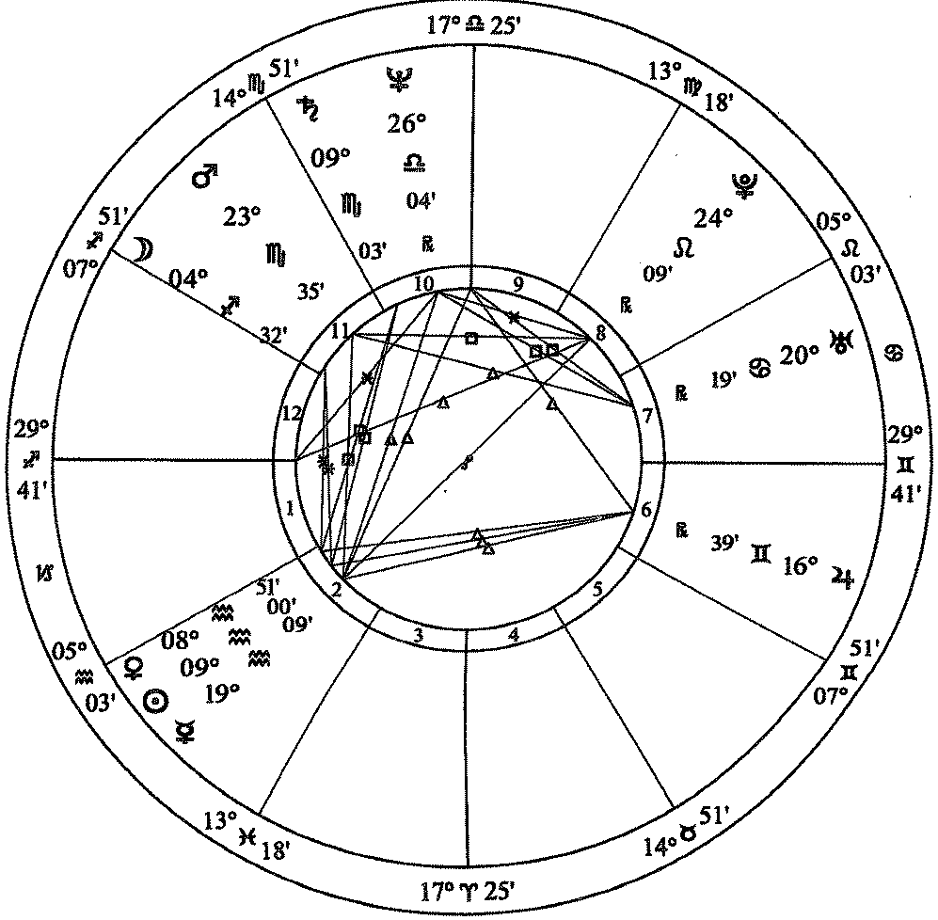

Oprah Winfrey

January 29, 1954 / 4:30 a.m. CST / Kosciusko, MS   
Placidus Houses

From *Llewellyn’s Complete Book of Astrology* by Kris Brandt Riske, MA, page 269

What does it mean if you are born on the cusp

year not always 365 days long

months vary in length, so zodiac months vary in length

most of the time, the end of the zodiac month can be anywhere from 19th to 23rd

if born in that period, are almost always between signs

may have some attributes of both signs

called being “born on the cusp”

can get clarity from the rest of the chart

also important in chart are the ascendent

sun sign that was just coming over the horizon at time of birth

may tell a lot about you

also important may be the moon sign at time of birth

Moon is about the emotions

moon sign tells about emotional self, about private self

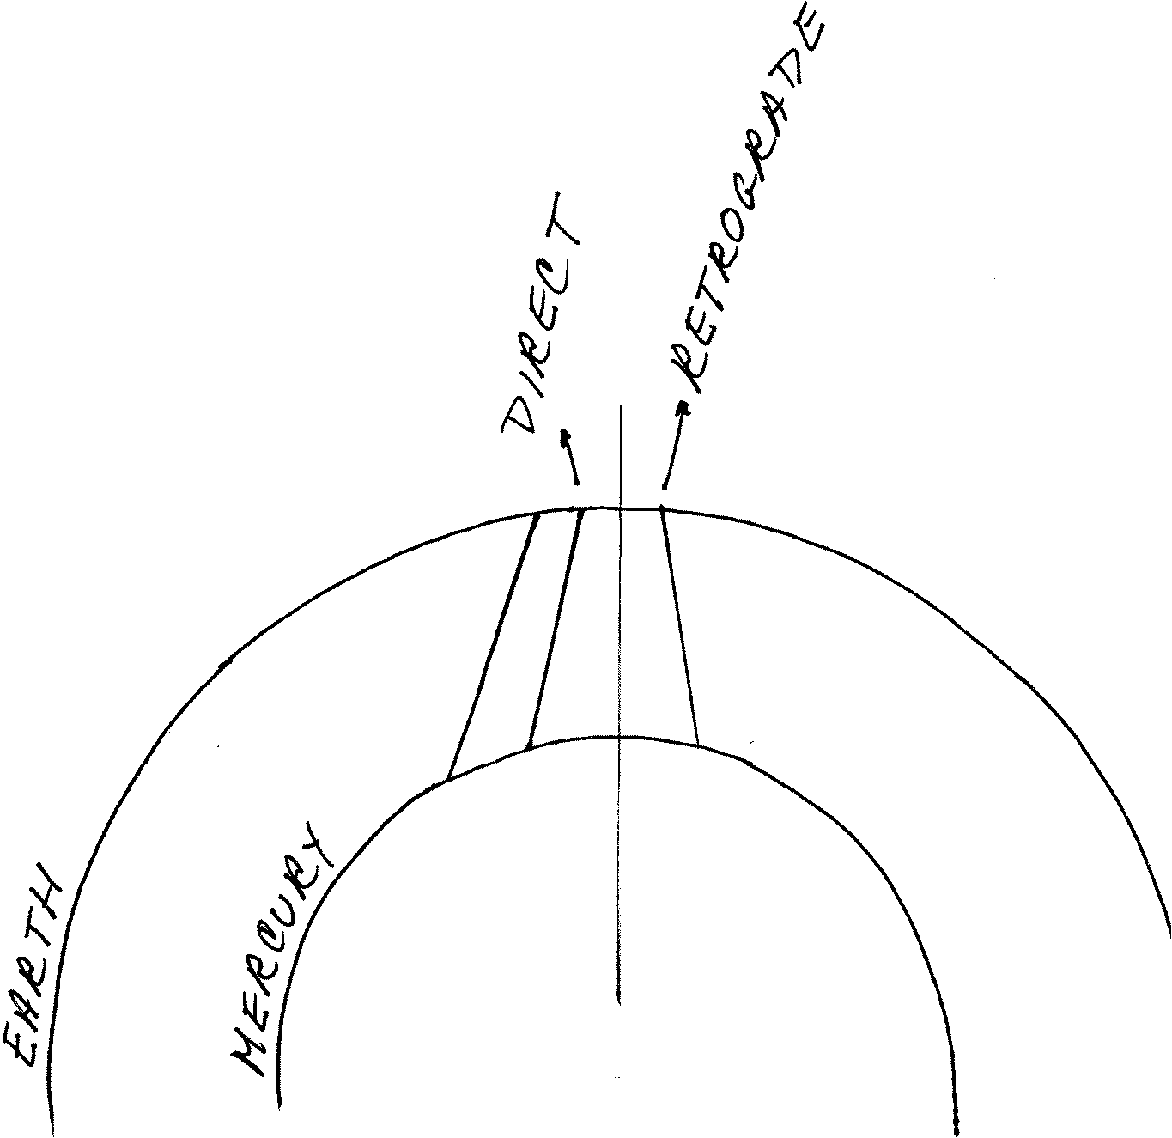

Based on Clement and Bytheriver, *Llewellyn’s New A to Z Horoscope Maker and Interpreter*, p 248

Based on Clement and Bytheriver, *Llewellyn’s A to Z Horoscope Maker and Interpreter*, p 248

Retrogrades

Mercury was retrograde at the start of this class

planet looks like it is going backwards based on our standing on earth

all planets do this except Sun and Moon

if standing on earth and try to see Mercury will have to look back over shoulder

Mercury represents communications/mental alertness

3 three-week periods each year

what does it mean:

all kinds of communication issues

meetings fall through

try to make travel connections can be an issue

all kinds of computer issues

generally mind is not as sharp as usual

need to check and recheck info

other planets do this also but for different lengths of time at different times

mean different things based on the planet that is retrograde

If you want to have an astrology reading

will get a natal chart that looks like the Oprah Winfrey one

planets and houses

best do a test reading, then ask yourself

does it sound like you

does it make sense to you

do you like the attitude/concepts of the astrologer

absolutely keep a recording of some kind

almost impossible to remember everything

especially helpful if feel that there are things you don’t understand

if you like the astrologer and want annual readings

ask for “solar return”

location of the planets at time of your birthday this year

planets will have moved from where they were are the time of birth

also called a progressed chart

one issue is that readings often (key word) are about people who are younger

hard to get good data after about 50 years old

especially if order a computer generated reading

most of the time seniors have already worked through many of the issues

seniors don’t worry much about work life/job issues

children are grown and making their own decisions

another issue is that the interpretations are often not consistent

most astrologers doing some kind of research

find a meaning for a planet or relationship

check with other readings and charts they do

if it works well, they then adopt that info and use it

may or may not share at e.g., at an association gathering

may or may not be accepted by others

readers have different meanings for the various planets

means will interpret the aspects differently

can get a computerized reading

then get interpretations of the person who designed the program

Healing Systems

called Complementary and Alternative Medicine (CAM)

some now covered by insurance

is not covered by Medicare

Part D may cover some types

check your insurance carefully for info

as with any healing system, traditional or not,

if you think it will work, helps to make it work more effectively

back to “Thoughts Are Things”

Healing Prayer

part of how I got into non-traditional beliefs

usually no cost involved

no training required, mostly need a desire to help

as part of a healing prayer group

basically think in a positive way about person with illness/challenge

can send wellness energy

can sending healing

better if think about the person in a positive way, not feeling sick

my own system is to find a visual image for person

support works even if I am still hunting for the image!

all this is distance

may or may not get feedback

may find that the person does not want any assistance

lady with the brick wall

just laid the energy on ground where she could reach it if she wished

use healing prayer because it is a very isolated event and

easy to see the dynamics that were at work

unique issue

get help

see results

but then it depends on whether you expect it to work

Reiki

touch healing system

Rei means “God’s Wisdom or the Higher Power”

Ki means “life force energy”

combined means “spiritually guided life force energy”

developed by Dr. Mikao Usui (1865 - 1926)

studied various religions

spiritual experience allowed him to do effective touch healing

before his death, passed the info to Dr. Chujiru Hayashi (1878 - 1940)

he then taught Hawayo Takta

had cured her of a serious illness using Reiki

she then taught it and her grand daughter, Phyllis Lei Furumoto, carried on

training system of three levels

Reiki I

Reiki II

Advanced Reiki Training/Master (ART/Master)

used to be that must then agree to teach to others

not sure of current requirement

have been a number of off shoots or enhancements

names usually have Reiki in the title of the system

two from the Reiki Association web site

Karuna Reiki - “compassionate action”

Holy Fire Reiki

reportedly some 300 derivatives world wide

I find it especially effective and worthwhile

lie on a table, wear comfortable clothing

healer touches various energy points on body

alternate: hands over energy point but not touch, just hover

may ask you to turn over

not invasive in any way

towel or cloth over face so healer can touch face without discomfort

may have more than one healer working at the same time

touch a spot, say forehead or shoulder blades

energy flows from hands of the healer into person being helped

healer holds that position until the flow slows down

when slows means that there has been sufficient energy

moves to another spot

as person being healed, wonderfully relaxing

once finished, feel very balanced, calm

actually does help

probably in part that relax totally

assists body’s own healing systems to be effective

calm, less anxiety about issues

feel that will improve

is generally a charge

friend who is a Reiki healer, we have talked about this

my healer did not want to be paid

discussed with mutual friend who is also a Reiki healer

there is a balance that occurs with giving and receiving

if don’t pay, then that balance is upset

person being helped feels a long term indebtedness

if pay for healing, don’t have that

friend and I usually went out to lunch afterward

said that if she would not let me pay for healing

I would not let her pay for her lunch

environment is important

made appointment for a Reiki associated with Sinai in Baltimore

near end, I was so calm and relaxed

healer wanted to try rolfing which was his speciality

basically aggressively rolled my arm between his hands

destroyed the relaxation of the Reiki

Therapeutic Touch

basically same idea as Reiki

difference is that it is taught to nurses mostly for inpatient use

developed by Dolores Krieger, PhD, RN and Dora Kunz

Nurse Healers Professional Associates International, Inc.

parent organization

sets standards and does credentialing

their sessions last no more than 20 minutes

large association

headquarters in Delmar, New York

Rolfing Structural Integration

system of deep manipulation of the body’s soft tissue

improves posture

relieves chronic pain

reduces stress

developed by Dr. Ida P. Rolf

Ph.D. in biochemistry in 1920

then learned osteopathy

chiropractic medicine

tantric yoga

Alexander tension reduction through body movement

Korzybski’s concept of altered states

created study of “general semantics”

our awareness limited by structure of nervous system

our awareness limited by structure of language

so what we know is filtered through brain/language

used: I don’t know, let’s see.......

Dr. Rolf realized that there were a series of integrated series of tissues

needed to work with all them to reduce stress and manifest healing

get them working together

heals what is called myofacial pain

touch points in the muscles and causes pain elsewhere

used deep massage to reshape the myofacial which reduces pain

Acupuncture

often part of pain management

insert very thin needles through skin

per those who have done it, feel needle go in or come out

not painful, just aware

done along meridians through the body

Chinese technique to balance qi or chi (pronounced CHEE)

Western practitioners use for stimulation

helps blood flow so natural pain killers function better

practitioner should use a fresh set of needles for each treatment

eliminate any danger of infection from previous use

Acupressure

similar to acupuncture but use pressure on the meridian points rather than needles

Reflexology

pressure points on the bottom of the feet are matched to organs

pressure on a particular point on foot sends healing to that organ

however, listed in University of Minnesota with article

list has supportive research

Quack Watch on Google

but then he did not expect it to work, so of course, it didn’t

Naturopathy

Naturopathy, or naturopathic medicine, is a system of medicine based on the healing power of nature. Naturopathy is a holistic system, meaning that naturopathic doctors (N.D.s) or naturopathic medical doctors (N.M.D.s) strive to find the cause of disease by understanding the body, mind, and spirit of the person.

Source: University of Maryland Medical Center

very wholistic, i.e., treat the whole person

practitioners are licensed

Homeopathy

Homeopathy is based on the idea that "like cures like." That is, if a substance causes a symptom in a healthy person, giving the person a very small amount of the same substance may cure the illness. source: WebMD

per NIH, little support evidence for any specific issue

remedies are regulated by FDA but not for safety or effectiveness

Ayurveda

believe that illness comes from lack of balance in energy types:

per University of Maryland Medical Center energy types include:

Vata -- Energy that controls bodily functions associated with motion, including blood circulation, breathing, blinking, and heartbeat. When vata energy is balanced, there is creativity and vitality. Out of balance, vata produces fear and anxiety.

Pitta -- Energy that controls the body's metabolic systems, including digestion, absorption, nutrition, and temperature. In balance, pitta leads to contentment and intelligence. Out of balance, pitta can cause ulcers and arouse anger.

Kapha -- Energy that controls growth in the body. It supplies water to all body parts, moisturizes the skin, and maintains the immune system. In balance, kapha is expressed as love and forgiveness. Out of balance, kapha leads to insecurity and envy.

General Resources:

Local classes: <http://www.peaceabledragon.org/class-archives/virginia-classes/>

<http://www.takingcharge.csh.umn.edu/>

Univ of Minn

comprehensive list of the various types of CAM, with links

research and support for various types

Johns Hopkins, Different Types of CAM

http://www.hopkinsmedicine.org/healthlibrary/conditions/adult/complementary_and_alternative_medicine/types_of_complementary_and_alternative_medicine_85,p00189/

NIH, exceptionally long list sorted by medical problem and various solutions

<https://nccih.nih.gov/health/atoz.htm>

WebMD

<http://www.webmd.com/balance/what-is-alternative-medicine>

Thoughts Are Things:

Dick Sutphen with Tara Sutphen, *Soul Agreements*, Hampton Roads Publishing Company, 2005

Three Initiates, *Kybalion*, The Yogi Publication Society, Masonic Temple, Chicago, IL

Alice Steadman, *Who’s the Matter with Me*

Astrology

Associations for Astrologers:

See list at: <http://stariq.com/PageTemplate/t1.asp?PageID=799>

American Federation of Astrologers

seems to have a training and testing program

may be easier to use one of their astrologers

none in the DC, one in Virginia area, are several in Maryland

Reiki:

<http://medical-dictionary.thefreedictionary.com/Reiki>

general info, good summary

<http://www.reiki.org/>

International Center for Reiki Training

Therapeutic Touch:

<http://therapeutic-touch.org/>

Rolfing:

<http://www.rolf.org/about>

<http://medical-dictionary.thefreedictionary.com/Rolfing>

http://www.drweil.com/drw/u/ART00472/Rolfing-Dr-Weils-Wellness-Therapies.html

Acupuncture:

http://www.mayoclinic.org/tests-procedures/acupuncture/basics/definition/prc-20020778

includes information on risks and potential side effects

<http://www.webmd.com/fibromyalgia/tc/acupuncture-topic-overview>

topic says fibromyalgia but article is about acupuncture

<http://www.medicalnewstoday.com/articles/156488.php>

lots of info

Acupressure:

http://www.webmd.com/balance/guide/acupressure-points-and-massage-treatment

<http://www.acupressure.com/>

a number of images on people using the pressure points

<http://www.drweil.com/drw/u/ART03230/Acupressure.html>

Reflexology:

http://www.takingcharge.csh.umn.edu/explore-healing-practices/reflexology

http://www.mayoclinic.org/healthy-lifestyle/consumer-health/expert-answers/what-is-reflexology/faq-20058139

Naturopathy:

<https://umm.edu/health/medical/altmed/treatment/naturopathy>

lots of info with good references

<https://nccih.nih.gov/health/naturopathy>

what a naturopath does and how he/she works

Homeopathy:

<http://www.nationalcenterforhomeopathy.org/>

<http://www.webmd.com/balance/guide/homeopathy-topic-overview>

<https://nccih.nih.gov/health/homeopathy>

comprehensive discussion

Ayurveda:

[www.chopra.com/our-services/ayurveda](http://www.chopra.com/our-services/ayurveda)

<http://www.webmd.com/balance/guide/ayurvedic-treatments>

<https://umm.edu/health/medical/altmed/treatment/ayurveda>

<https://nccih.nih.gov/health/ayurveda/introduction.htm>

comprehensive article