L608, Survey of Non-Traditional Beliefs
Agenda:

1. Class I, September 22
Introduction
Sources
Mystical Traditions
What Is a Mystic
Classical Elements

2. Class II, September 29
Karma
Resolution of Karma

3. Class III, October 6
Reincarnation
Akashic Records

4. Class IV, October 13
Free Will Choice
Understanding Karma, Reincarnation and Free Will Choice
Changing Your Energy

5. Class V, October 20
Changing Your Energy
Gender and Mental Gender
Astrology
Healing Systems

6. Class VI, October 27
Chakras
Kundalini
Energy Layers in Body
Mystery Schools
Lesser Mysteries/Greater Mysteries
Ley Lines

Linda Bender
lindabender@starpower.net
Phone: 703-451-0253
NOTES:

Chakras

Chopra Center:
“To visualize a chakra in the body, imagine a swirling wheel of energy where matter and consciousness meet. This invisible energy, called Prana, is vital life force, which keeps us vibrant, healthy, and alive.”

there are seven of them

some of the Who’s the Matter with Me material is tied to chakra locations
throat and heart in particular

you have:
two single pages that were hand out items:
color print of body with placement
chart based on the info from Mitra

easier to follow with the separate charts

are also in your handout after the Mitra info

Chakras

From material held by the Jains

Jainism is an ancient religion from India that teaches that the way to liberation and bliss is to live a life of harmlessness and renunciation. The aim of Jain life is to achieve liberation of the soul.
www.bbc.co.uk/religion/religions/jainism/BBC

concepts “released” sometime in 1970s
former monk by the name of Chitrabhanu came to US from India
founded Jain Meditation Center in NY in 1973

March 7, 1980, St Andrews Methodist Church (somewhere in northern Virginia!)

First Chakra: MUDLAHARA
Location: base of the spine
Element: earth
Human sense: smell

Visualization: yellow square or cube, sit on it and let it grow larger
sense of four sides: north, east, south, west
alternate: yellow circle with cross inside

Mantra: SHEE-VUM’ SHANTI
feeling of joy peace, tranquility
love

Notes: benediction to earth
if being successful, then sense of smell is intensified
if sense of smell goes, then need to work with first chakra
if give out peace to earth, then get back security
use when you feel fear
security is not in “things” we own, security is within

Second Chakra: SWADISHTANA
Location: below the navel
Element: water
Human sense: taste

Visualization: body of water at night with a crescent moon
may see self in the moon
see the light on the water
moon grows to full and then you become the moonlight

Mantra: MANO RAMUM
in mind player in the mind

Notes: place of one’s own residence
creative energy
therefore sexual
therefore build security and then enjoy
psychologically is feelings of self esteem
all the fluids related to creative and sexual energy
sense of taste intensified
lovers must be secure with each other
if not there is no sexual energy
when in touch with this chakra
get a increase in self esteem
get sense of direction
increase your own individuality
sense of joy

Third Chakra: MANIPURA (city of jewels and the jewels reflect light)
Location: from navel up to base of rib cage
Element: fire
Human sense: sight

Visualization: fire around sides of a triangle

Mantra: RAM
given to life to this center, mind and body

Notes: power center, communication
fire center
OK to be helpless, but must take responsibility and ride it out
can always transcend it
once take responsibility can usually change it
slowly but it works
umbilical cord center
if want control, let go of the control
control self, not others
people who always plan ahead, think ahead, because want to
be in control are stuck in the 3rd chakra
fire = agni
in yoga
use this with 3rd eye to burn up old tapes
to burn up old tapes:
SITKARA: burning of the snake
1. relax and open up 3rd chakra
say RAM, RAM,.... until chakra opens
2. take a deep breath
picture the experience just had and all the feelings see flames burn the picture
3. take a breath and let it out with a hiss
burns any left overs
breathe through nose
disturbs other chakras if breathe through mouth
story of monkey and jar of chick peas:
monkey sticks his hand in the jar and grabs peas
mouth of jar is too small
if hold onto peas, cannot get hand out
let go and will find jewels
give space for own divinity
will empty self and there will be room
Fourth Chakra: ANAHUT or ANAHATA
(resounds with beautiful feelings of love)
Location: heart
Element: air
Human sense: touch

Visualization: sky blue pearl, expand until merges with air around it
sparkling point of white light

Mantra: SO HUM
that I am
SO: inhale: life
HUM: exhale: I am

Notes: get in touch with feelings
opens the heart center, then develop psychic skills
inhale fresh life, exhale poisons and toxins
plug into this center and will when plug into divinity
we are a drop in a grand ocean
but drop and ocean are the same stuff,
merge and then can’t tell the boundary between two
become one
heart has wisdom that is incredible, let it out
if do not love, cannot breathe and cannot live

when love looks up , it is reverence
when love looks down, it is benevolence
when love looks eye to eye, it is acceptance
use I Corinthians 13 for a definition of love

Fifth Chakra: VISHUDHI
Location: throat
Element: aether
Human sense: hearing

Visualization: oval, scarlet or mauve or transparent
expand to infinite

Mantra: AIM (said fast and short)
element of wisdom
wisdom through experience on the feeling level
(not through knowledge)

Notes: purity of purity
essence of essence
creative will center, will create activity within body
everything around, inside, and within, means that get a cup
relationship between inner and outer space of person
implies personality, body shape, etc.
as get in touch with this chakra:
words are more powerful
in harmony with everything, even worst enemy
give space to everything and every one
pick up clairvoyance
see time: past, future, present
get meaning behind “Time does not exist”
there is no form, divinity is everywhere
are in it
when open the 4th chakra, then throat works better
don’t feel as much pain
learn to say things so it is easiest for others
use words they will appreciate and understand
no paranoia
need to be totally open to the first four chakras
then won’t misuse this one
give space and acceptance to self and to others, has four parts

give space to self | give space to others
|
________________________|_________________________
|
give acceptance to self | give acceptance to others
Sixth Chakra: AGNA (the command post)
Location: third eye
Element:

Visualization: concentric circular rainbow with all the colors
red at outside, white light in the middle
may see a silver star

alternate:
two beams of light out to right and left
curl around and meet in back
then move through brain center and back to third eye
makes a white light at point on forehead

Mantra: PRAGNA SUKURNUMUM
wisdom bliss, tranquil joyfulness

Notes: sense of discrimination
can see self in movie of own life
can eliminate unhealthy thoughts
can open and use to deal with difficult person
can look at own body and find illness
master
does control of all thoughts
works like a projector

Seventh Chakra: SHASTRADA
Location: crown (same as soft spot on baby’s head)
Element:

Visualization: lotus with 1,000 petals, self is at center

Mantra: OM ARHUM’ NAMAH
universe that which is I surrender to pure spirit
with in
with out

Notes: sense of true being
place of consciousness
level of cosmic consciousness
rare
sense of painter be painted by the painting
no sense of separation, only a sense of one-ness
true bliss, totally aware of everything

- 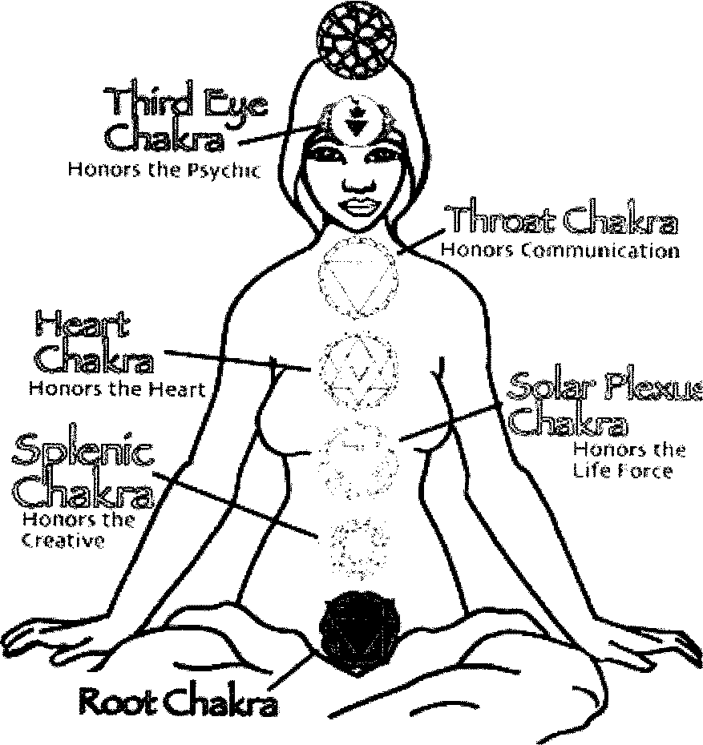
Honors the Earth

Chakra | Color | Location | Element | Endocrine  Astara | Chopra Center
crown | violet | crown |  | pineal | pure consciousness
brow | indigo/ navy blue | third eye |  | pituitary | intuition, sixth sense
throat | blue | throat | ether | thyroid | communication, speak highest truth
heart | green | heart | air | thymus | compassion, love self and others
solar plexus | yellow | naval up to base of rib cage | fire | solar plexus?  adrenals? | power/warrior
navel | orange | below the naval | water | naval, extend into spleen | creativity, hence sexual as well
root | red | base of spine | earth | gonads | base, groundedness

Sources:
Robert Mitra, Jain Center, 1980
Chopra Center, Michelle Fondin, National Ayurvedic Medical Association

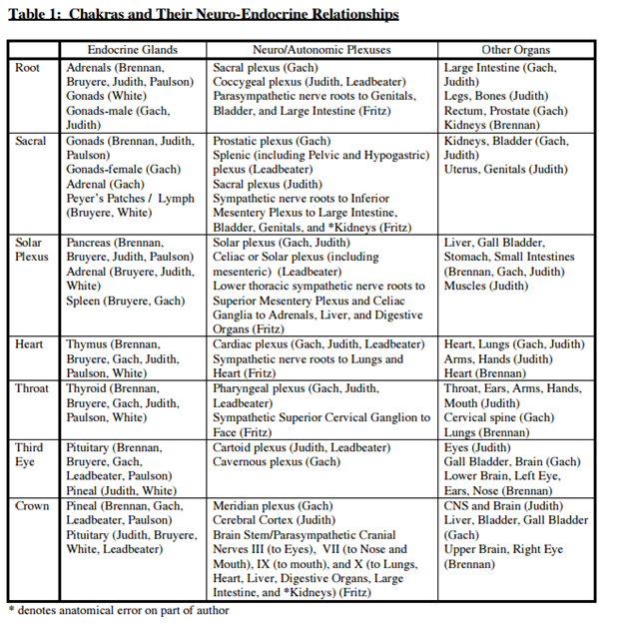
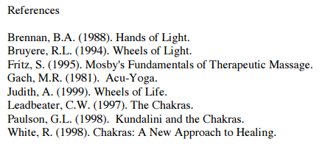

Kundalini

uses meditation on the chakras and particular Yoga postures to train/stimulate

there is a curled bit of nerve near the base of the spine
it uncurls and touches the spinal cord
causes an energy rush up the chakras

better not to work with it unless you have a teacher who is skilled with it
needs to happen slowly and gently
need to open the chakras slowly and deal with all the issues

can cause problems if fires off and you are not ready

compare to mystical experience
does not seem to be the same thing at all:
mystical experience is oneness experience with the Godhead
this is something involving the energy centers that go up spine

Energy Layers in Body

Mystery Schools

school with closely held wisdom and teachings
passed down in oral tradition from teacher to student
train by taking years of learning and resolving issues
learn to use the powers
physical initiation
involves testing
ancient schools used a mystical death and rebirth
based on hints from what I have read
involves a kind of ritual death
go beyond that by understanding what is real and what is not
are then via images reborn

long list of mystery schools on the Internet

if you want to do this,
not do it lightly, takes a commitment
3-4-5 year project, need to pay for the training and membership in the school
lots of getting in touch with yourself and your issues and old karma
develop some hefty honesty with yourself
consider the 4 rabbis who went into the divine orchard or paradise:
one went mad immediately
one died immediately
one cut down the plants
one found peace

search for a mystery school that fits you
lots of them around now
need to research
need to ask to talk to some of the long term members/students
be sure they teach the greater mysteries:
Bardo
death process

Astara
Astara.org
on the home page, left side
click on: Press here for highlights of the Degree Lessons
gives some quoted material from the lessons
near top at the center is link to their latest newsletter
among other things lists the titles of all the lessons, 8 years worth
two lessons in one booklet are $11.97
can get half year for $47 in one bound book
can get whole year for $77 in one book
Lesser Mysteries/Greater Mysteries

Lesser Mysteries
taught by drama or by story/parable
parables in the Bible are examples
not necessarily explained
learning/understanding of message occurred later
understand as run into a similar situation

current examples in movies and novels, get such things as:
Jedi Master Yoda training Luke in Star Wars series

James Redfield
The Celestine Prophecy
The Tenth Insight
The Secret of Shambhala
The Twelfth Insight (new)
Richard Bach
Jonathan Livingston Seagull, is now a Part 4
Illusions: The Adventures of a Reluctant Messiah
One
Illusions II
psychics:
Edgar Cayce
Jane Roberts, Seth material
Arthur Ford

Greater Mysteries
ancient teachers watch for those ready to learn
tested
trained, usually a multi year process
initiations/ceremonies
concerns about misuse of the knowledge and skills so much was held secret
were passwords
were vows not to release info
could be dangerous
also see it in books that are difficult to read and/or hard to understand
needed to really concentrate to get the message
actually written to had to work to understand

now info is being released
e.g., chakra info held by Jain
weekend lecture session in 1980
NDEs
Proof of Heaven

read what works for you
trying to wade through the Seth material (Jane Roberts)
could manage about 4 pages and mind all over the place
finally told to put it away
get the same kind of leanring from Jonathan Livingston Seagull
which I loved

if pick up info or get an “I wonder whether......”
ask for confirmations

Ley Lines

none of this is proven

concept:
from Sir Alfred Watkins, amateur archeologist (1855-1935)
book in 1922, Early British Trackways
revised and enhanced in The Old Straight Track, published in 1925
showed that straight lines connected some of the powerful ancient sites
his idea that they were pathways that people could walk
not a lot of scientific support for his ideas

if look on the Internet under ley lines
almost a manipulation of data to prove what you want to prove
did statistics for a research project
sort and resort so the project leaders could show what they wanted to show
really reduced my trust in any kind of statistical analysis
lots of different answers
lots of different maps
a certain amount of scepticism
major questions about whether they exist or not
one site said are fault lines associated with tectonic plates
and then used by UFOs for navigation

area in New Mexico
N/S line that appears to connect sacred sites
not necessarily a ley line

are locations with powerful energy
Stonehenge
Glastonbury Tor, UK
Ayers Rock, Australia
Nazca Lines, Peru
Egyptian pyramids at Giza
energy diffused by crowds

Chartres Cathedral, France
continued to build sacred/worship places in the same location
build up a strong positive energy
Mt St Albans, Washington Cathedral
down in the Joseph of Arimathea Chapel, under the crossing
different from energy up on the main floor
crypt: Helen Keller and Anne Sullivan Macy
Dome of the Rock, Jerusalem, top of Mt. Moriah
walking around, interesting, touristy
sacred to many faiths
site of two Jewish Temples
Abraham to have sacrificed Isaac there (Genesis 22:1–14
Mohammed taken by angle Gabriel to see God and prophets
went into the Dome of the Rock
went downstairs to actual rock
saw how rock was carved/adjusted to allow for sacrifices
draining blood, managing the meat, etc
energy so strong that I had to hold onto a wall, almost fell over
in the middle of the group so I could move to the side

Resources:

General:

http://www.themystica.com/mystica/default.html
actually pretty comprehensive, uses and has awards from Encyclopedia Britannica

http://www.crystalinks.com/directory.html

Kundalini
http://www.swamij.com/index-yoga-meditation-kundalini.htm
most detailed info I found

Mystery Schools:
Astara.org

Lesser Mysteries
http://www.starwars.com/news/the-starwars-com-10-best-yoda-quotes
Yoda training Luke

