Plato’s Republic
A Study Group
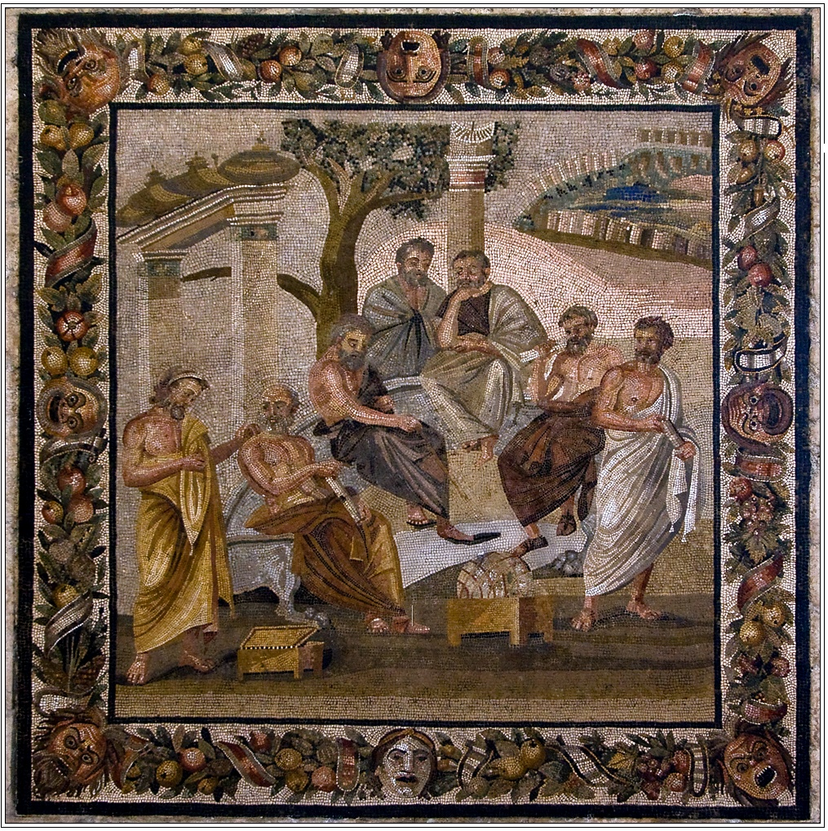
Osher Lifelong Learning Institute
at
George Mason University
Fall 2008 – Spring 2009
Bob Lawshe, Facilitator
Does it not belong to the rational part to rule, being wise and exercising forethought in behalf of the entire soul, and to the principle of high spirit to be subject to this and its ally? … And these two … will preside over the appetitive part which is the mass of the soul in each of us and the most insatiate by nature of wealth.
Goal
Our goal in this class to read and study Plato’s Republic over the course of the Fall 2008 and Winter and Spring 2009 terms. Class members are expected to have their own copy of The Republic, recommended text below, and to read assigned portions of the work prior to classes. Since there are 10 “books” in the Republic, we will try to cover each book over two class sessions, but this may not work out in practice, so we will have to be flexible. During classes we will discuss that week’s reading and try to figure out just what is going on. There will be no rushing; if a particular section takes a bit longer to get through we will spend the necessary time on it. Out goal is to try and understand what Plato is intending and to have fun doing it.
Because we are using the Study Group format, class members will be expected to volunteer to do research and to take a leading role in weekly discussions. This is particularly important as I will be unable to attend every session.
The class represents a serious year long commitment to studying this work. But if you miss some, so be it, after all I’ll have to miss some as well! New class members can join the discussion at any point during the class and attendance in the fall term isn’t a prerequisite for the winter or spring terms, etc.
Introduction
Plato’s Republic centers on a simple question: is it always better to be just than unjust? The puzzles in Book One prepare for this question, and Glaucon and Adeimantus make it explicit at the beginning of Book Two. To answer the question, Socrates takes a long way around, sketching an account of a good city on the grounds that a good city would be just and that defining justice as a virtue of a city would help to define justice as a virtue of a human being. Socrates is finally close to answering the question after he characterizes justice as a personal virtue at the end of Book Four, but he is interrupted and challenged to defend some of the more controversial features of the good city he has sketched. In Books Five through Seven, he addresses this challenge, arguing (in effect) that the just city and the just human being as he has sketched them are in fact good and are in principle possible. After this long digression, Socrates in Books Eight and Nine finally delivers three “proofs” that it is always better to be just than unjust. Then, because Socrates wants not only to show that it is always better to be just but also to convince Glaucon and Adeimantus of this point, and because Socrates’ proofs are opposed by the teachings of poets, he bolsters his case in Book Ten by indicting the poets’ claims to represent the truth and by offering a new myth that is consonant with his proofs.
…(T)he center of Plato’s Republic is a contribution to ethics: a discussion of what the virtue justice is and why a person should be just. Yet because Socrates links his discussion of personal justice to an account of justice in the city and makes claims about how good and bad cities are arranged, the Republic sustains reflections on political questions, as well. Not that ethics and politics exhaust the concerns of the Republic. The account in Books Five through Seven of how a just city and a just person are in principle possible is an account of how knowledge can rule, which includes discussion of what knowledge and its objects are. Moreover, the indictment of the poets involves a wide-ranging discussion of art.
Structure of the Republic
The Republic is a wide-ranging and comprehensive dialogue full of scenes and topics of discussions.
The work has perhaps 4 (or 5 or 3) basic sections.
 |  | 1 |  | Forward: What is justice? Is it profitable?
 |  | 2
Argument: Both the individual and the city comprise forces potentially at odds with one another: social classes in the city and parts of the soul in the person. Justice consists for both in harmony among those forces. But when they do not come into a harmonious relation, the result will be unhappiness; the greater the anarchy, the greater the misery. Therefore, justice is profitable.
 |  | 3
 |  | 4
 |  |  |  | Digression: The just city will differ from existing cities in its treatment of women, children, and property in the ruling class. The rulers will be philosophers, because only philosophy can issue in knowledge of the Forms and of what is good in life.
 |  | 5
 |  | 6
 |  | 7
 |  | 8
 |  | 9
 |  | 10 |  | Afterward: Poetry and immortality.

Francis Cornford, Kurt Hildebrandt and Eric Voegelin developed the following subdivisions of the work. (While the Grube and Reeve edition does not make use of these subdivision I think they are useful in understanding the overall structure of the book.)
Section 1: Book I – Introduces the characters and the issues that will be taken up particularly: What is Justice? And is it better to be just than unjust?
Prologue
I. 327a—328b. Descent to the Piraeus
I. 328b—331d. Cephalus. Justice of the Older Generation
I. 331e—336a. Polemarchus. Justice of the Middle Generation
I. 336b—354c. Thrasymachus. Justice of the Sophist
Section 2: Books II–IV – Lays out the construction of the perfectly just city.
Introduction
II. 357a—369b. The Question: Is Justice Better than Injustice?
Genesis and Order of the Polis
II. 369b—376e. Genesis of the Polis
II.—III. 376e—412b. Education of the Guardians
III.—IV. 412b—427c. Constitution of the Polis
IV. 427c—445e. Justice in the Polis
Section 3: Books V–VII – Consists of a philosophical digression about wisdom, universals and particulars, the idfference between images and originals and the Idea of the the Good.
Embodiment of the Idea
V. 449a—471c. Somatic Unit of Polis and Hellenes
V.—VI. 471c—502c. Rule of the Philosophers
VI.—VII. 502c—521c. The Idea of the Agathon
VII.—VII. 521c—541b. Education of the Philosophers
Section 4: Books VIII–X – Takes us back to politics and a discussion of regimes as well as of the immortality of the soul and the Myth of Er.
Decline of the Polis
VIII.1—VIII.5. 543a—550c. Timocracy
VIII.6—VIII.9. 550c—555b. Oligarchy
VIII.10—VIII.13. 555b—562a. Democracy
VIII.I4—IX-3. 562a—576b. Tyranny
Conclusion
IX. 576b—592b Answer: Justice is Better than Injustice
Epilogue
X. 595a—608b. Rejection of Mimetic Art
X. 608c—612a. Immortality of the Soul
X. 612a—613e. Rewards of Justice in Life
X. 613e—621d. Judgment of the Dead
Dr. Bernard Suzanne has divided the Republic somewhat, but not completely, differently. His division and discussion of the division can be found at his web site “Plato’s Dialogues” at http://www.plato-dialogues.org/tetra_4/republic/plan.htm. I have reproduced it below with the addition of Book numbers. Note that Book numbers do not exactly match up with the subdivisions..
Plans of the Republic
“Visible” Plan |  |  | “Intelligible” Plan
BOOK I – (327a-354c)
Introduction: the five challenges | 327a-367e (37) |  |  | Introduction: the five challenges | 327a-367e (37)
Prologue: the setting | 327a-328c ( 1) |  |  | Prologue: the setting | 327a-367e (37)
-- Cephalus: ambiguity, social justice, fear of Hades | 328c-331d ( 3) |  |  | -- Cephalus: ambiguity, social justice, fear of Hades | 328c-331d ( 3)
-- Polemarchus: uncertainty, give each one his due | 331d-336a ( 4) |  |  | -- Polemarchus: uncertainty, give each one his due | 331d-336a ( 4)
-- Thrasymachus: duplicity, law of the stronger, justice for others | 336b-354c (18) |  |  | -- Thrasymachus: duplicity, law of the stronger, justice for others | 336b-354c (18)
BOOK II – (357a-383c)
-- Glaucon: evading responsibility, justice is a necessary evil, Gyges | 357a-362c ( 5) |  |  | -- Glaucon: evading responsibility, justice is a necessary evil, Gyges | 357a-362c ( 5)
-- Adeimantus: make believe, ambiguity of poets, example of the Gods | 362d-367e ( 5) |  |  | -- Adeimantus: make believe, ambiguity of poets, example of the Gods | 362d-367e ( 5)
I. The building of the ideal city | 367e-427c (56) |  |  | I. The building of the ideal city | 367e-427c (56)
-- Genesis of the city | 367e-376c ( 9) |  |  | -- Genesis of the city | 367e-376c ( 9)
BOOK III – (386a-417b)
-- Education of the guardians | 376c-412b (34) |  |  | -- Education of the guardians | 376c-412b (34)
BOOK IV – (419a-445e)
-- Administrators and laws of the city | 412c-427c (13) |  |  | -- Administrators and laws of the city | 412c-427c (13)
II. Justice in city and soul | 427c-445e (18) |  |  | II. Justice in city and soul | 427c-445e (18)
-- Justice in the city | 427d-434c ( 7) |  |  | -- Justice in the city | 427d-434c ( 7)
-- The three parts of the soul | 434d-441c ( 7) |  |  | -- The three parts of the soul | 434d-441c ( 7)
-- Justice in the soul | 441c-445e ( 4) |  |  | -- Justice in the soul | 441c-445e ( 4)
BOOK V – (449a-480a)
A. 1st wave: same education for men and women | 449a-457c ( 8) |  |  | The conditions of feasibility | 449a-502c (49)
(Against Cephalus: “phusis” vs. “ousia”) |  |  |  | “People won’t deem what I say feasible” (450c)
 |  |  |  | 1. “Phusis”: same education for men and women | 449a-457c ( 8)
B. 2nd wave: community of women and children | 457d-471c (14) |  |  | 2. “Koinônia”: community of women and children | 457d-471c (14)
(Against Polemarchus: “all in common” vs. “each one his due”)
BOOK VI – (484a-511e)
C. 3rd wave: the philosopher-king | 471c-543c (63) |  |  | The paradigm: the philosopher-king | 471c-474c ( 3)
1. The philosopher and the city | 471c-502c (26) |  |  | “Won’t by nature action have a lesser share with truth than speech?” (473a)
(Against Thrasymachus: wisdom vs. strength) |  |  |  | 3. “Dunamis”: knowledge vs. opinion, philosopher vs. friends of opinion | 474d-480a ( 6)
 |  |  |  | BOOK VI – (484a-511e)
 |  |  |  | 4. “Theou moira”: the philosopher and the crowd | 484a-502c (18)
 |  |  |  | “Our model of legislation, if feasible, is the best one, and, though hard to implement, yet is not impossible” (502c)
BOOK VII – (514a-541b)
2. The yearning for the good | 502c-521b (17) |  |  | III. The yearning for the good | 502c-521b (17)
(Against Glaucon: the cave vs. Gyges) |  |  |  | -- The image of the good | 502c-509b ( 7)
 |  |  |  | -- The analogy of the line: visible and intelligible worlds | 509c-511e ( 2)
 |  |  |  | BOOK VII – (514a-541b
 |  |  |  | -- The cave: the paradigm of education | 514a-521b (7)
3. The education of the philosopher-king | 521c-543c (20) |  |  | IV. The becoming of city and man | 521c-580c (55)
(Against Adeimantus: dialectic vs. poetry) |  |  |  | -- Education of the philosopher-king (monarchy) | 521c-543c (20)
BOOK VIII – (543a-569c)
III. Corruption of city and man | 543c-580c (35)
-- From timocracy followed by oligarchy... | 543c-555a (12) |  |  | -- From timocracy and oligarchy... | 543c-555a (12)
-- ...to democracy followed by tyranny | 555b-580c (23) |  |  | -- ...to democracy and tyranny | 555b-580c (23)
BOOK IX – (571a-592b)
Conclusion: the five answers | 580d-621d (38) |  |  | Conclusion: the five answers | 580d-621d (38)
-- To Polemarchus: each part its due | 580d-583a ( 3) |  |  | -- To Polemarchus: each part its due | 580d-583a ( 3)
-- To Cephalus: true and false “ousia” | 583b-588a ( 5) |  |  | -- To Cephalus: true and false “ousia” | 583b-588a ( 5
-- To Thrasymachus: tamed strength | 588b-592b ( 4) |  |  | -- To Thrasymachus: tamed strength | 588b-592b ( 4)
BOOK X – (595a-621d)
-- To Adeimantus: true and false teachers | 595a-607b (12) |  |  | -- To Adeimantus: true and false teachers | 595a-607b (12)
-- To Glaucon: each one his chosen fate | 607b-621d (14) |  |  | -- To Glaucon: each one his chosen fate | 607b-621d (14)

And here is his speaker chart from the same website. This page redisplays the above plans, with some changes, and adds an indication of whom Socrates is talking to in each section of the dialogue, and where changes of interlocutor take place. It does so for both plans:
“Visible” Speaker Plan of The Republic |  |  | G158/A81
BOOK 1 – (327a-354c)
Introduction: the five challenges |  | 327a-369b (39) |  |  | G5/A5
Prologue: the setting |  | 327a-328c ( 1)
-- Cephalus: ambiguity, social justice, fear of Hades |  | 328c-331d ( 3) |  |  | Cephalus
-- Polemarchus: uncertainty, give each one his due |  | 331d-336a ( 4) |  |  | Polemarchus
-- Thrasymachus: duplicity, law of the stronger, justice for others |  | 336b-354c (18) |  |  | Thrasymachus
1st part: Thrasymachus’ definition of justice |  | 336b-340a (4) |  |  | Thrasymachus
Intervention of Polemarchus and Cleitophon |  | 340a-c (0.5) |  |  | Polem., Cleit.
2nd part: why choose justice? |  | 340c-347a (6.5) |  |  | Thrasymachus
Intervention of Glaucon |  | 347a-348b (1) |  |  | Glaucon
3rd part: the fate of the unjust |  | 348b-354c (6) |  |  | Thrasymachus
BOOK I1 – (357a-383c)
-- Glaucon: evading responsibility, justice is a necessary evil, Gyges |  | 357a-362c ( 5) |  |  | Glaucon
-- Adeimantus: make believe, ambiguity of poets, example of the Gods |  | 362d-367e ( 5) |  |  | Adeimantus
I. The building of the ideal city |  | 367e-427c (56) |  |  | G23/A31
Transition: the city, larger letters for the soul |  | 367e-369b (2) |  |  | G., A., others
-- Genesis of the city |  | 369b-376c ( 7)
1st part: the basic needs |  | 369b- 372c (3) |  |  | Adeimantus
2nd part: refinements (Glaucon breaks in afraid of that “city of pigs”) |  | 372c-376c (4) |  |  | Glaucon
BOOK II1 – (386a-417b)
-- Education of the guardians |  | 376c-412b (34)
1st part: “musical” education (1st part: logos - criticism of the poets) |  | 376c-398b (20) |  |  | Adeimantus
2nd part: “musical” education (2nd part: harmony, rhythm) - Gymnastic |  | 398c-412b (14) |  |  | Glaucon
-- Administrators and laws of the city |  | 412c-427c (13)
1st part: choice of leaders - the “noble lie” - community of guardians |  | 412c-417b (5) |  |  | Glaucon
BOOK IV – (419a-445e)
2nd part: organisation of the state (A. breaks in afraid the guardians won’t be happy) |  | 419a-427c (8) |  |  | Adeimantus
II. Justice in city and soul |  | 427c-445e (18) |  |  | G18/A0
-- Justice in the city |  | 427d-434c ( 7) |  |  | Glaucon
-- The three parts of the soul |  | 434d-441c ( 7) |  |  | Glaucon
-- Justice in the soul |  | 441c-445e ( 4) |  |  | Glaucon
BOOK V – (449a-480a)
Transition: joint efforts of Polemarchus, Adeimantus, Thrasymachus and Glaucon |  | 449a-450c (1) |  |  | P., A., Th., G.
A. 1st wave: same education for men and women |  | 450c-457c ( 7) |  |  | G7/A0
(Against Cephalus: “phusis” vs. “ousia”) |  |  |  |  | Glaucon
B. 2nd wave: community of women and children |  | 457d-471c (14) |  |  | G14/A0
(Against Polemarchus: “all in common” vs. “each one his due”) |  |  |  |  | Glaucon
BOOK VI – (484a-511e)
C. 3rd wave: the philosopher-king |  | 471c-543c (63) |  |  | G44/A19
1. The philosopher and the city |  | 471c-502c (26)
(Against Thrasymachus: wisdom vs. strength)
1st part: nature of the philosopher - knowledge and opinion |  | 471c-487a (11) |  |  | Glaucon
2nd part: the philosopher and the state |  | 487b-502c (15) |  |  | Adeimantus
BOOK VII – (514a-541b)
2. The yearning for the good |  | 502c-521b (17)
(Against Glaucon: the cave vs. Gyges)
1st part: the necessity for leaders to know the good |  | 502c-506d (4) |  |  | Adeimantus
2nd part: analogy of the sun - the line - the allegory of the cave |  | 506d-521b (13) |  |  | Glaucon
3. The education of the philosopher-king |  | 521c-543c (20) |  |  | Glaucon
(Against Adeimantus: dialectic vs. poetry)
BOOK VIII – (543a-569c)
III. Corruption of city and man |  | 543c-580c (35) |  |  | G9/A26
-- From timocracy... |  | 543c-548d (5) |  |  | Glaucon
--... and the timocratic man through oligarchy and the oligarchic man, democracy and the democratic man down to tyranny and the tyrannic... |  | 548d-576b (26) |  |  | Adeimantus
BOOK IX – (571a-592b)
-- ...man and his life |  | 576b-580c (4) |  |  | Glaucon
Conclusion: the five answers |  | 580d-621d (38) |  |  | G38/A0
-- To Polemarchus: each part its due |  | 580d-583a ( 3) |  |  | Glaucon
-- To Cephalus: true and false “ousia” |  | 583b-588a ( 5) |  |  | Glaucon
-- To Thrasymachus: tamed strength |  | 588b-592b ( 4) |  |  | Glaucon
BOOK X – (595a-621d)
-- To Adeimantus: true and false teachers |  | 595a-607b (12) |  |  | Glaucon
-- To Glaucon: each one his chosen fate |  | 607b-621d (14) |  |  | Glaucon

“Intelligible” Speaker Plan of The Republic |  |  | G158/A81
BOOK I – (327a-354c)
Introduction: the five challenges | 327a-369b (39) | G5/A5
Prologue: the setting | 327a-328c ( 1)
-- Cephalus: ambiguity, social justice, fear of Hades | 328c-331d ( 3) | Cephalus
-- Polemarchus: uncertainty, give each one his due | 331d-336a ( 4) | Polemarchus
-- Thrasymachus: duplicity, law of the stronger, justice for others | 336b-354c (18) | Thrasymachus
1st part: Thrasymachus’ definition of justice | 336b-340a (4) | Thrasymachus
Intervention of Polemarchus and Cleitophon | 340a-c (0.5) | Polem., Cleit.
2nd part: why choose justice? | 340c-347a (6.5) | Thrasymachus
Intervention of Glaucon | 347a-348b (1) | Glaucon
3rd part: the fate of the unjust | 348b-354c (6) | Thrasymachus
BOOK II – (357a-383c)
-- Glaucon: evading responsibility, justice is a necessary evil, Gyges | 357a-362c ( 5) | Glaucon
-- Adeimantus: make believe, ambiguity of poets, example of the Gods | 362d-367e ( 5) | Adeimantus
I. The building of the ideal city | 367e-427c (56) | G23/A31
Transition: the city, larger letters for the soul | 367e-369b (2) | G., A., others
-- Genesis of the city | 369b-376c ( 7)
1st part: the basic needs | 369b- 372c (3) | Adeimantus
2nd part: refinements (Glaucon breaks in afraid of that “city of pigs”) | 372c-376c (4) | Glaucon
BOOK III – (386a-417b)
-- Education of the guardians | 376c-412b (34)
1st part: “musical” education (1st part: logos - criticism of the poets) | 376c-398b (20) | Adeimantus
2nd part: “musical” education (2nd part: harmony, rhythm) - Gymnastic | 398c-412b (14) | Glaucon
-- Administrators and laws of the city | 412c-427c (13)
1st part: choice of leaders - the “noble lie” - community of guardians | 412c-417b (5) | Glaucon
BOOK IV – (419a-445e)
2nd part: organisation of the state (A. breaks in afraid the guardians won’t be happy) | 419a-427c (8) | Adeimantus
II. Justice in city and soul | 427c-445e (18) | G18/A0
-- Justice in the city | 427d-434c ( 7) | Glaucon
-- The three parts of the soul | 434d-441c ( 7) | Glaucon
-- Justice in the soul | 441c-445e ( 4) | Glaucon
BOOK V – (449a-480a)
Transition: joint efforts of Polemarchus, Adeimantus, Thrasymachus and Glaucon | 449a-450c (1) | P., A., Th., G.
The conditions of feasibility | 450c-502c (48) | G33/A15
“People won’t deem what I say feasible” (450c)
1. “Phusis”: same education for men and women | 450c-457c ( 7) | Glaucon
2. “Koinônia”: community of women and children | 457d-471c (14) | Glaucon
The paradigm: the philosopher-king | 471c-474c ( 3) | Glaucon
“Won’t by nature action have a lesser share with truth than speech? “ (473a)
3. “Dunamis”: knowledge vs. opinion, philosopher vs. friends of opinion | 474d-480a ( 6) | Glaucon
BOOK VI – (484a-511e)
4. “Theou moira”: the philosopher and the crowd | 484a-502c (18) | Glaucon
1st part: nature of the philosopher - knowledge and opinion | 484a-487a ( 3) | Glaucon
2nd part: the philosopher and the state | 487b-502c (15) | Adeimantus
“Our model of legislation, if feasible, is the best one,
and, though hard to implement, yet is not impossible” (502c)
III. The yearning for the good | 502c-521b (17) | G12/A4
-- The image of the good | 502c-509b ( 7)
1st part: the necessity for leaders to know the good | 502c-506d (4) | Adeimantus
2nd part: analogy of the sun | 506d-509c (3) | Glaucon
-- The analogy of the line: visible and intelligible worlds | 509c-511e ( 2) | Glaucon
BOOK VII – (514a-541b)
-- The cave: the paradigm of education | 514a-521b (7) | Glaucon
IV. The becoming of city and man | 521c-580c (55) | G29/A26
-- Education of the philosopher-king (monarchy) | 521c-543c (20) | Glaucon
BOOK VIII – (543a-569c)
-- From timocracy... | 543c-548d (5) | Glaucon
... and the timocratic man through oligarchy and the oligarchic man,  -- democracy and the democratic man, down to tyranny and the tyrannic... | 548d-576b (26) | Adeimantus
BOOK IX – (571a-592b)
...man and his life | 576b-580c (4) | Glaucon
Conclusion: the five answers | 580d-621d (38) | G38/A0
-- To Polemarchus: each part its due | 580d-583a ( 3) | Glaucon
-- To Cephalus: true and false “ousia” | 583b-588a ( 5) | Glaucon
-- To Thrasymachus: tamed strength | 588b-592b ( 4) | Glaucon
BOOK X – (595a-621d)
-- To Adeimantus: true and false teachers | 595a-607b (12) | Glaucon
-- To Glaucon: each one his chosen fate | 607b-621d (14) | Glaucon

Here is a different approach to the above:
Plans of the Republic
 | BOOK I – (327a-354c)
 | Introduction: the five challenges |  |  |  |  | 327a-367e (37)
 | Prologue: the setting |  |  |  |  | 327a-328c ( 1)
 | -- Cephalus: ambiguity, social justice, fear of Hades |  |  |  |  | 328c-331d ( 3)
 | -- Polemarchus: uncertainty, give each one his due |  |  |  |  | 331d-336a ( 4)
 | -- Thrasymachus: duplicity, law of the stronger, justice for others |  |  |  |  | 336b-354c (18)
 | BOOK II – (357a-383c)
 | -- Glaucon: evading responsibility, justice is a necessary evil, Gyges |  |  |  |  | 357a-362c ( 5)
 | -- Adeimantus: make believe, ambiguity of poets, example of the Gods |  |  |  |  | 362d-367e ( 5)
 | I. The building of the ideal city |  |  |  |  | 367e-427c (56)
 | -- Genesis of the city |  |  |  |  | 367e-376c ( 9)
 | BOOK III – (386a-417b)
 | -- Education of the guardians |  |  |  |  | 376c-412b (34)
 | BOOK IV – (419a-445e)
 | -- Administrators and laws of the city |  |  |  |  | 412c-427c (13)
 | II. Justice in city and soul |  |  |  |  | 427c-445e (18)
 | -- Justice in the city |  |  |  |  | 427d-434c ( 7)
 | -- The three parts of the soul |  |  |  |  | 434d-441c ( 7)
 | -- Justice in the soul |  |  |  |  | 441c-445e ( 4)
“Visible” Plan |  |  |  | “Intelligible” Plan
BOOK V – (449a-480a)
A. 1st wave: same education for men and women |  | 449a-457c ( 8) |  |  | The conditions of feasibility |  |  | 449a-502c (49)
(Against Cephalus: “phusis” vs. “ousia”) |  |  |  |  | “People won’t deem what I say feasible” (450c)
 |  |  |  |  | 1. “Phusis”: same education for men and women |  |  | 449a-457c ( 8)
B. 2nd wave: community of women and children |  | 457d-471c (14) |  |  | 2. “Koinônia”: community of women and children |  |  | 457d-471c (14)
(Against Polemarchus: “all in common” vs. “each one his due”)
BOOK VI – (484a-511e)
C. 3rd wave: the philosopher-king |  | 471c-543c (63) |  |  | The paradigm: the philosopher-king |  |  | 471c-474c ( 3)
1. The philosopher and the city |  | 471c-502c (26) |  |  | “Won’t by nature action have a lesser share with truth than speech?” (473a)
(Against Thrasymachus: wisdom vs. strength) |  |  |  |  | 3. “Dunamis”: knowledge vs. opinion, philosopher vs. friends of opinion |  |  | 474d-480a ( 6)
 |  |  |  |  | BOOK VI – (484a-511e)
 |  |  |  |  | 4. “Theou moira”: the philosopher and the crowd |  |  | 484a-502c (18)
 |  |  |  |  | “Our model of legislation, if feasible, is the best one, and, though hard to implement, yet is not impossible” (502c)
BOOK VII – (514a-541b)
2. The yearning for the good |  | 502c-521b (17) |  |  | III. The yearning for the good |  |  | 502c-521b (17)
(Against Glaucon: the cave vs. Gyges) |  |  |  |  | -- The image of the good |  |  | 502c-509b ( 7)
 |  |  |  |  | -- The analogy of the line: visible and intelligible worlds |  |  | 509c-511e ( 2)
 |  |  |  |  | BOOK VII – (514a-541b)
 |  |  |  |  | -- The cave: the paradigm of education |  |  | 514a-521b (7)
3. The education of the philosopher-king |  | 521c-543c (20) |  |  | IV. The becoming of city and man |  |  | 521c-580c (55)
(Against Adeimantus: dialectic vs. poetry) |  |  |  |  | -- Education of the philosopher-king (monarchy) |  |  | 521c-543c (20)
BOOK VIII – (543a-569c)
III. Corruption of city and man |  | 543c-580c (35)
-- From timocracy followed by oligarchy... |  | 543c-555a (12) |  |  | -- From timocracy and oligarchy... |  |  | 543c-555a (12)
-- ...to democracy followed by tyranny |  | 555b-580c (23) |  |  | -- ...to democracy and tyranny |  |  | 555b-580c (23)
 | BOOK IX – (571a-592b)
 | Conclusion: the five answers |  |  |  |  | 580d-621d (38)
 | -- To Polemarchus: each part its due |  |  |  |  | 580d-583a ( 3)
 | -- To Cephalus: true and false “ousia” |  |  |  |  | 583b-588a ( 5)
 | -- To Thrasymachus: tamed strength |  |  |  |  | 588b-592b ( 4)
 | BOOK X – (595a-621d)
 | -- To Adeimantus: true and false teachers |  |  |  |  | 595a-607b (12)
 | -- To Glaucon: each one his chosen fate |  |  |  |  | 607b-621d (14)

Greek Words
Phusis – cosmos , cycles of nature, nature, often translated as “birth”. Martin Heidegger made the argument in An Introduction to Metaphysics that the translation of phusis as something mundane and simplistic caused harm to our understanding of early Greek philosophy and decided that the word should be translated as ‘emerging-abiding-sway’ and that it provided a more complex and accurate understanding of existence than the earlier translation.
Ousia – essence, nature, savour, substance, a noun formed on the feminine present participle for the Greek verb “to be”, (such a participle in English, is “being”).
Koinônia – partnership or fellowship.
Dunamis – power or force. It is the root of “dynamic”.
Theou moira – will, volition; destiny. The deity who assigns to every person his lot. Devine will.
Text and Further Reading
Text
Grube, G.M.A, revised by Reeve, C.D.C, Plato Republic, Hackett Publishing Company, Indianapolis/Cambridge, 1992
This edition was recommended by Dr. Rose Cherubin, of the GMU Philosophy Department. If you use another translation be sure it has Stephanus numbers (those funny 396a, 441d, numbers usually in the margins). A note of caution – To quote Dr. Cherubin – “I wouldn’t use Jowett. While his prose is often beautiful, it is often seriously misleading. Jowett is notorious for removing or altering all references to same-sex romantic attachments. Another problem is that he sometimes treats references to techne (art, craft, skill, artisanry) as references specifically to “fine art,” when in fact techne includes also things like farming and carpentry.”
For Commentary on The Republic you can try:
Pappas, Nickolas, Routledge Philosophy Guidebook to Plato and the Republic, second edition, Routledge, London and New York, 2003
Santas, Gerasimos, ed., The Blackwell Guide to Plato’s Republic, Blackwell Publishing, Oxford, 2006
Ferrari, G.R.F., ed., The Cambridge Companion to Plato’s Republic, Cambridge University Press, Cambridge and New York, 2007
Websites
There are lots of web sites on Plato’s Republic. Here are just a few.
Stanford Encyclopedia of Philosophy – http://plato.stanford.edu/entries/plato-ethics-politics/
Internet Encyclopeida of Phiolosophy – http://www.iep.utm.edu/
An Electronic Companion to Plato’s Republic – http://krypton.mnsu.edu/~witt/plato’s_republic.htm
University of Florida class notes – http://luna.cas.usf.edu/~demilio/2211unit2/plato.htm
Classics Technology Center – http://ablemedia.com/ctcweb/netshots/republic.htm
The Perseus Project for complete translations – http://www.perseus.tufts.edu/
A site on the history, nature, and institutions, and a lot more on Greece – http://www.stoa.org
A wonderful site on things Plato, not to be missed – http://www.plato-dialogues.org/
Dr. Cherbin’s website – http://www.gmu.edu/courses/phil/ancient/index.htm
And you can always try:
CliffsNotes – http://education.yahoo.com/homework_help/cliffsnotes/republic/
Spark Notes – http://www.sparknotes.com/philosophy/republic/
Location of Plato’s Academy
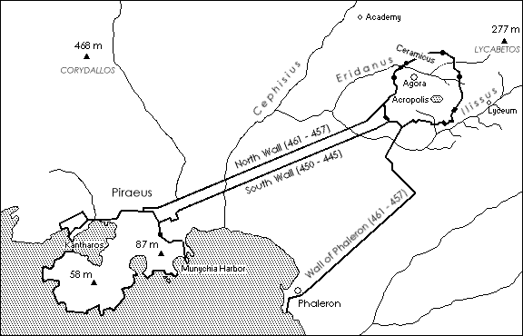
Overview of Athens and the Piraeus
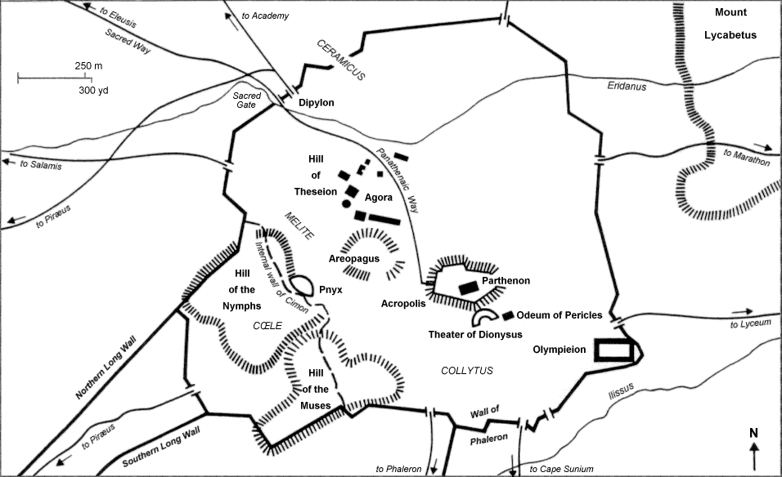
Downtown Athens
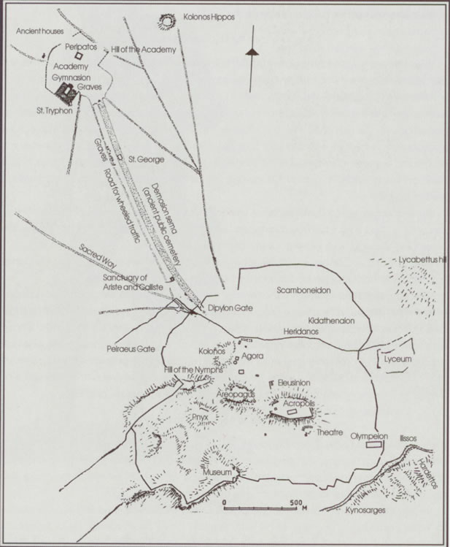
Academy, and Lyceum, in relation to downtown Athens
Title page image:
Plato’s Academy,
Pompeii, Villa of T. Siminius Stephanus
1st century BCE – 1st century CE
mosaic, Museo Archeologico Nazionale di Napoli

From The Stanford Encyclopedia of Philosophy, http://plato.stanford.edu/entries/plato-ethics-politics/
Pappas, Nickolas, Pappas, Nickolas, Routledge Philosophy Guidebook to Plato and the Republic, second edition, Routledge, London and New York, 2003. Page 23.
Note: the numbers in parentheses after the Stephanus references to the beginning and end of each section or subsection give the approximate number of Stephanus pages of that section or subsection
Note: the numbers in parentheses after the Stephanus references to the beginning and end of each section or subsection give the approximate number of Stephanus pages of that section or subsection. The Gnn/App figures in the right column facing the head title and section titles give the approximate length of discussion with Glaucon (G) and Adeimantus (A) respectively in the whole dialogue or that section, using the same unit (number of pages).
Note: the numbers in parentheses after the Stephanus references to the beginning and end of each section or subsection give the approximate number of Stephanus pages of that section or subsection

