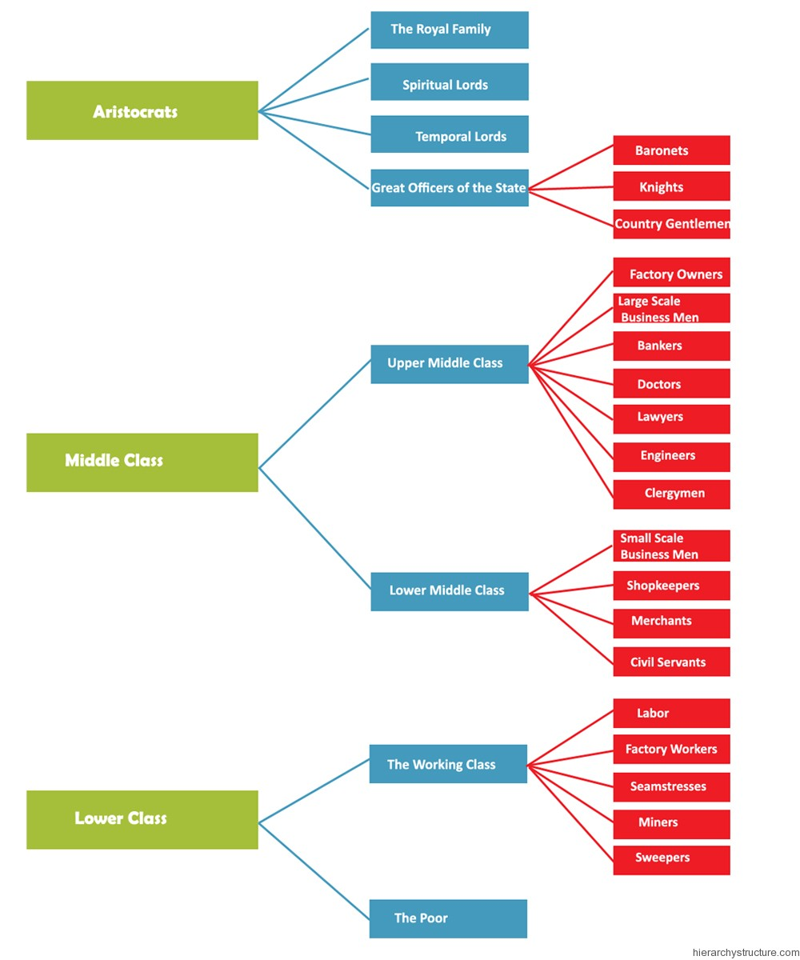

Source: http://www.hierarchystructure.com/19th-century-england-social-hierarchy/

