THE SHOWRUNNERS
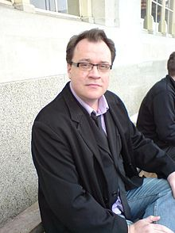
Stephen Russell Davies, OBE (born 27 April 1963), better known by his pen name Russell T Davies, is a Welsh television producer and screenwriter whose works include Queer as Folk, Bob & Rose, The Second Coming, Casanova, the 2005 revival of the classic British science fiction series Doctor Who, and the trilogy Cucumber, Tofu, and Banana. He revived and ran Doctor Who after a sixteen-year hiatus, with Christopher Eccleston, and later David Tennant, in the title role. Davies's tenure as executive producer of the show oversaw a surge in popularity that led to the production of two spin-off series, Torchwood and The Sarah Jane Adventures, and the revival of the Saturday prime-time dramas as a profitable venture for production companies. Davies was awarded an OBE (Officer of the Order of the British Empite) in 2008 for services to drama.

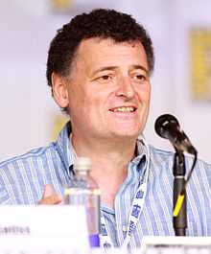
Steven William Moffat, OBE, was born 18 November 1961.. He is a Scottish television writer and producer, known for his work as showrunner, writer and producer of the British television series Doctor Who and Sherlock. Moffat is a lifelong fan of Doctor Who. His first work on the series was the script of the parody episode The Curse of Fatal Death in 1999. He then wrote six episodes of the revived series which began in 2005 ("The Empty Child", "The Doctor Dances", "The Girl in the Fireplace", "Blink", "Silence in the Library", and "Forest of the Dead"). In 2010 he replaced Russell T Davies as showrunner, lead writer and executive producer. The same year, he created Sherlock along with Mark Gatiss. In January 2016, it was announced that Moffat would step down from being showrunner of Doctor Who after the spring 2017 season finale, and that Broadchurch creator Chris Chibnall would take over. He also co-wrote Steven Spielberg's The Adventures of Tintin: The Secret of the Unicorn in 2011. Moffat has won several awards, mainly for Doctor Who and Sherlock, including an Emmy Award, five BAFTA Awards and four Hugo Awards. In June 2015, Moffat was appointed an OBE (Officer of the Order of the British Empire) for his services to drama.

Chris Chibnall was born in 1970. He is an English television writer. He is best known for his work on the science-fiction series Doctor Who, its spin-off Torchwood and the ITV detective serial Broadchurch. On January 22, 2016, it was announced that he would become the full-time show runner of Doctor Who. His first series will air in Spring 2018.

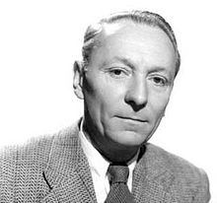
William Henry Hartnell (8 January 1908 – 23 April 1975), was an English actor. Hartnell played the first incarnation of the Doctor in Doctor Who, from 1963 to 1966. He was also known for his roles as Sergeant Grimshaw, the title character of the first Carry On film, Carry on Sergeant in 1958, and Company Sergeant Major Percy Bullimore in the sitcom The Army Game from 1957 until 1958, and again in 1960. Hartnell's deteriorating health (he suffered from arteriosclerosis, which began to affect his ability to learn his lines), as well as poor relations with a new production team on the series following the departure of Verity Lambert, ultimately led to his leaving Doctor Who in 1966. When he departed, the producer of the show came up with a unique idea: that since the Doctor is an alien, he can transform himself physically, thereby renewing himself. William Hartnell himself suggested the new Doctor, stating that "There's only one man in England who can take over, and that's Patrick Troughton". In the fourth episode of the serial The Tenth Planet, the First Doctor regenerated into Troughton's Second Doctor.
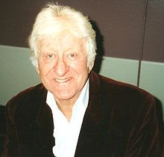
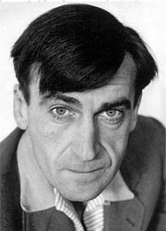
Patrick George "Pat" Troughton (25 March 1920 – 28 March 1987) was an English actor most widely known for his roles in fantasy, science fiction, and horror films, particularly in his role as the second incarnation of the Doctor in the long-running British science-fiction television series Doctor Who, which he played from 1966 to 1969; he reprised the role in 1973 (The Three Doctors), 1983 (The Five Doctors), and 1985 (The Two Doctors).

