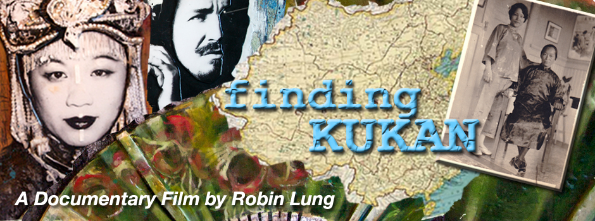

A reflection on lost history and the power of art, this feature documentary follows a filmmaker’s quest to bring recognition to the unheralded woman behind the making of KUKAN, a long-lost Academy Award-winning color documentary about World War II China.

www.nestedeggproductions.com

