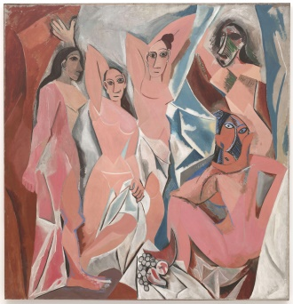
READ MORE…
PABLO PICASSO
The Essential Pablo Picasso, Ingrid Schaffner
Picasso : the early years, 1892-1906
Picasso Museum, Paris : The Masterpieces, Bernadac, Marie-Laure
In Montmartre, Picasso, Matisse and the Birth of Modernist Art, Sue Roe
Matisse, Picasso – The Story of Their Rivalry and Friendship, Jack Flam
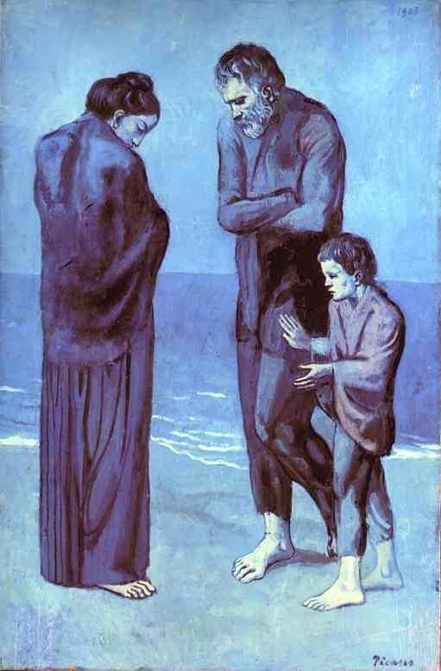

LEARN MORE…
http://www.pablopicasso.org
https://www.khanacademy.org/humanities/art-1010/early-abstraction/cubism/a/picassos-early-work
http://www.wikiart.org/en/pablo-picasso
http://www.abcgallery.com/P/picasso/picasso.html

SEE MORE…

Washington, DC
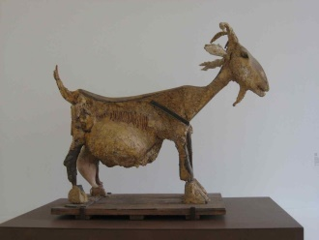
National Gallery of Art

New York

Museum of Modern Art

Current exhibit – Picasso Sculpture through 2/7/16

The Metropolitan Museum of Art

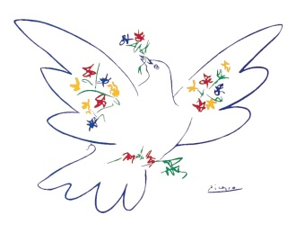
Pennsylvania

The Philadelphia Museum of Art

