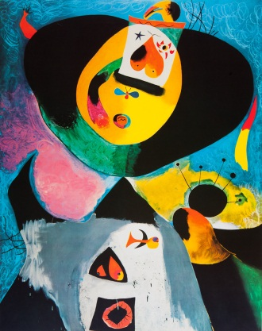
READ MORE…
JOAN MIRÓ
Joan Miró The Ladder of Escape, National Gallery of Art, Tate Publishing
Miró, Walter Erben & Hajo Duchting
Miró, Gaston Diehl
Miró Sculpture, Alain Joufroy & Joan Teixidor

LEARN MORE…
www.bcn.fjmiro.es/
http://www.joan-miro.net/
http://www.nga.gov/exhibitions/2012/miro/
http://www.nga.gov/content/ngaweb/audio-video/video/joan-miro.html - video we watched
www.abcgallery.com/M/miro/miro.html
http://www.theartstory.org/artist-miro-joan.htm

SEE MORE…

Washington, DC
National Gallery of Art
Hirshhorn Museum and Sculpture Garden
The Phillips Collection

New York
Museum of Modern Art
Metropolitan Museum of Art

