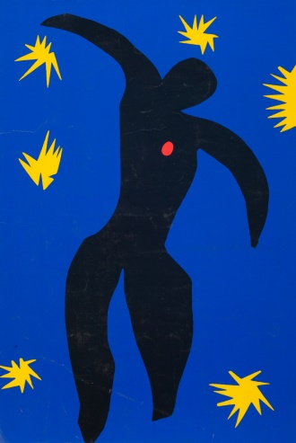
HENRI MATISSE
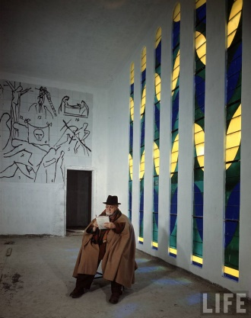
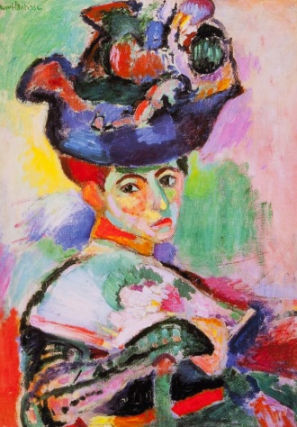
READ MORE…
Matisse Cut-Outs, Gilles Neret
Matisse the Master, A Life of Henri Matisse, Hilary Spurling
Henry Matisse, Roger Benjamin
The Essential Henri Matisse, Ingrid Schaffner
Matisse, Jean Selz
Matisse, La Danse, Frederico Zeri

In Montmartre, Picasso, Matisse and the Birth of Modernist Art, Sue Roe
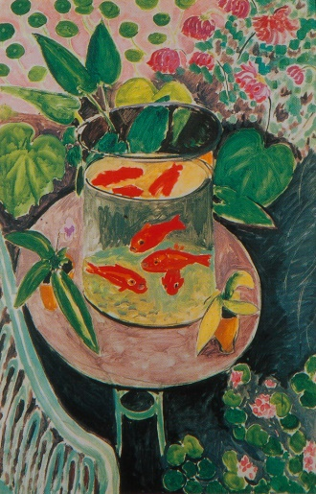
Matisse, Picasso – The Story of Their Rivalry and Friendship, Jack Flam

LEARN MORE…
http://www.henri-matisse.net
www.musee-matisse-nice.org
www.abcgallery.com/M/matisse/matisse.html
www.nga.gov/feature/artnation/fauve/index.html - The Fauves

SEE MORE…

An Essay on Picasso, Perry Wolff, 1996. 57 min

Washington, DC
National Gallery of Art
Phillips Collection

Maryland
Baltimore Museum of Art

Pennsylvania
Philadelphia Museum of Art

New York
Metropolitan Museum of Art
Museum of Modern Art
Union Church of Pocantico Hills, New York

