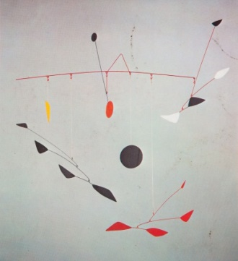
ALEXANDER CALDER
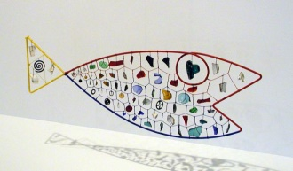
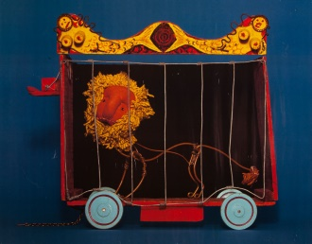
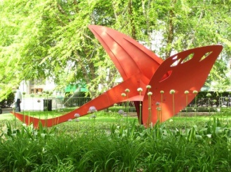
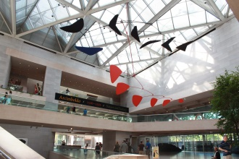
READ MORE…
The Essential Alexander Calder, Howard Greenfeld
Calder Sculpture, National Gallery of Art
Calder at Home, Pedro E Guerrero
Three Alexander Calders, A Family Memoir, Margaret Calder
Hayes

Children’s books
Roarr: Calder’s Circus, Maira Kalman
Sandy's Circus: a Story about Alexander Calder, Tanya Stone

LEARN MORE…
www.calder.org
www.nga.gov/feature/artnation/calder/
http://collection.whitney.org/artist/215/AlexanderCalder?page=5
http://www.wikiart.org/en/alexander-calder
www.artcyclopedia.com/artists/calder_alexander.html
http://www.phillyhistory.org/blog/index.php/2008/06/from-sculptor-to-mobile-creator-three-generations-of-calder-artists/
http://www.som.com/ideas/slideshows/art__som_working_with_alexander_calder

SEE MORE…

Washington, DC
National Gallery of Art and Sculpture Garden
The Phillips Collection
Smithsonian American Art Museum

Pennsylvania
Philadelphia Museum of Art

New York
Whitney Museum of American Art
The Museum of Modern Art

List of public Calder works https://en.wikipedia.org/wiki/List_of_Alexander_Calder_public_works

