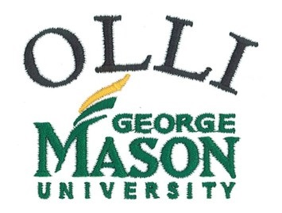 |  |  | OLLI Spirit Wear  Fall 2015
Name:
Telephone:
Email:
Polo Shirt $30  with embroidered logo  Men’s Polo  Sizes: S,M,L,XL,XXL*,XXXL*  Colors: Kelly Green, Black, Red, Strong Blue  Women’s Polo  Sizes: XS, S, M, L, XL, XXL*  Colors: Kelly Green, Black, Red, Strong Blue  *$2 additional for larger sizes |  |  |  |  | T-Shirt $20  with embroidered logo  Sizes: S,M,L,XL,XXL*,XXXL*  Colors: Kelly Green, Jet Black, Red, Royal Blue  *$2 additional for larger sizes |  |  | Caps $20  Colors: Kelly Green, Red, Royal Blue, Black  Totes $30  Colors: Kelly Green, Black, Cardinal Red, Royal Blue  with  embroidered logo
QTY | Color | Size Item (men or women polo) |  |  |  | UNIT PRICE |  |  | TOTAL
- Order form with payment must be received at the Tallwood office by Friday, October 23, 2015. (OLLI Office, 4210 Roberts Rd ,Fairfax VA 22032)  - Checks payable to OLLI |  |  |  |  |  |  | total  Enclosed

